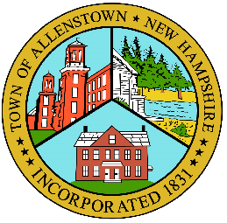

Town of Allenstown
Board of Selectmen
16 School St.
Allenstown, NH 03275
603-485-4276

PUBLIC HEARINGS
TOWN OF ALLENSTOWN, NH
“RSA 31:95-b Section III, Unanticipated Acceptance of Funds More than $10,000”
The Selectboard will hold two public hearings under RSA 31:95-b Section III held on Monday, May 16, 2022, at Allenstown Town Hall at 6:00PM to accept and expend American Rescue Plan Act funds.
1. Acceptance of ARPA/NH GOFERR Funds under the Locality Equipment Purchase Program and expending for eligible activities: Total Expected: $49,021 but up to $50,000 from the Locality Equipment Program to purchase portable radios for the police and fire department. The town will be matching 10% at a cost of $4,902 to obtain the radios.
2. Selectboard authorizing expending $58,000 of the Town’s ARPA Funds for NonEntitlement Communities on Valley Street Slip Lining of Storm Drainage $39,000 under the Loss of Revenue Grant Category.
Board of Selectmen
Town of Allenstown, NH

