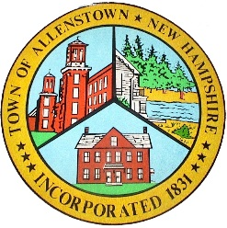
-

Town of Allenstown
Debbie Bender, Finance Director
16 School Street
Allenstown, NH 03275
603-485-4276 ext. 120
dbender@allenstownnh.gov

TO: Trustee of Trust Funds

FROM: Allenstown Board of Selectmen

DATE: April 23, 2018

The Board of Selectmen are requesting that the Recycling Capital Reserve Fund be discontinued and that the balance in this account be transferred to the Highway Dept Equip Capital Reserve Fund, in accordance with the votes taken at Town Meeting on March 13th, 2018.

Reserve Fund |  | Balance 3/31/18 |  | Article Number
FROM: Recycling |  | -$20,709.09 |  | 10
TO: Highway Dept Equip |  | +$20,709.09 |  | 11
NET |  | 0.00

Please coordinate with the Finance Director to process the transactions.

________________________________
Ryan Carter, Chairperson

________________________________
David Eaton /Selectman

________________________________
Sandra McKenney/Selectman

