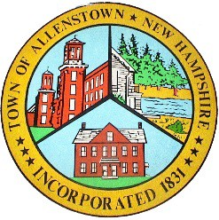
Town of Allenstown

Town Administrator 16 School Street
Allenstown, NH 03275
603-485-4276 ext. 112
TA@allenstownnh.gov

QUORUM NOTICE
There will be a quorum of the Selectboard
On Tuesday, September 13, 2022,
From 7AM to 7PM and potentially later at the Primary Election
at St. John the Baptist Parish Hall
NOTICE IS HEREBY GIVEN that a quorum of the Select Board, will be present at the Primary Elections held at St. John the Baptist Parish Hall at 10 School Street in Allenstown, New Hampshire.

THE SELECT BOARD doesn’t intend to conduct any business, and there is no agenda
for Selectboard.

Derik Goodine Town Administrator
www.allenstownnh.gov

