Town of Allenstown
Town Administrator
16 School Street
Allenstown, NH 03275
603-485-4276 ext. 112
TA@allenstownnh.gov

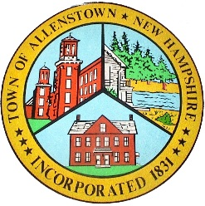

Select Board
Notice of Public hearing
Town Hall, 16 School St.
Monday, 6:00 o’clock p.m., August 13, 2018

Public Hearing – RSA 41:14-a, Lincoln Street Hammerhead Project/Land Swap
***************************************
Notice of Special Selectmen’s Meeting¹

Town Hall, 16 School St.
Wednesday, 6:00² o’clock p.m., August 22, 2018
Agenda to include

- RSA 41:14-a, Lincoln Street Hammerhead
Project/Land Swap
- Holiday Acres
Notices Regarding the Conduct of the Meeting.

- Meetings may be electronically recorded in any manner for the purpose of preparing written minutes. A record of the meeting is available for public inspection not later than five (5) business days after the meeting, as required by RSA 91-A:2, II. Minutes are ordinarily approved at the next Regular Meeting of the Board.
- If you require accommodations under the Americans with Disabilities Act of 1990 (as amended), please contact the Town Administrator by telephone (603-485-4276 ext. 112) or email (ta@allenstownnh.gov).

The Select Board reserves the right to hold any non-public session during the Regular Meeting, whether noted on the Agenda or not. Notice of a non-public session on an agenda is for planning purposes only. The citations to the Right-to-Know Law, set out at NH RSA 91-A, are provisional and may be revised as circumstances require.
Any time noted on an agenda is approximate only, and may not reasonably create an expectation that an item will be reached at that time. Items are normally taken up in the order in which they appear unless modified by the Select Board. New business is not considered after 9:00 p.m.

