TOWN OF ALLENSTOWN
Planning Board
16 School Street
Allenstown, New Hampshire 03275
October 04, 2017
Call to Order.

The Allenstown Planning Board Meeting for October 04, 2017 was called to order by Chair Mike O’Meara at 6:31 p.m.

Roll Call.

Present on the Board: Diane Adinolfo, Chad Pelissier*, Mike Frascinella, and Mike O’Meara
*Chad joined immediately after Roll Call and prior to any discussion/deliberation.

Ex-Officio: Ryan Carter (Not Present)

Others Present.

Residents of Allenstown: None (see below)

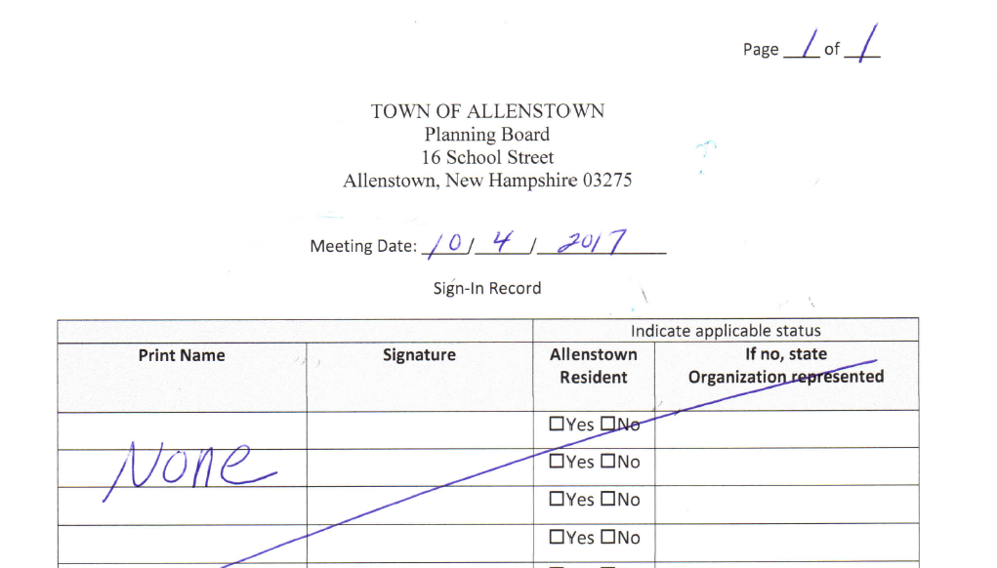
Others Present: Matt Monahan (by telephone, as previously agreed with the Chair)
Other Public Officials: None

Allenstown Staff: None

Note: Prior to conducting business, the Chair requested, and a moment of silence was observed, for the victims and families of the Las Vegas shooting incident.

OLD BUSINESS/RECIEPT OF APPLICATIONS & PUBLIC HEARINGS
- Adoption of various revisions to the Allenstown Planning Board’s regulations.
Rules of Procedure, Subdivision Regulations, and the Site Plan Regulations.

Open Public Hearing:
In conjunction with board member review of the proposed changes, the Chair opened the Public Hearing portion of the meeting at 6:33 p.m.

The Chair requested that Matt Monahan review the proposed changes to the regulations.

Note: Copies of the proposed changes are attached as Appendix A of these meeting minutes, and are briefly summarized below as presented by the Planner.

Rules of Procedure:
Page 1 – Add “Allenstown Planning Board” to title & revise “Updated” date to 04 October 2017.
Page 3 – Update date on “Certificate of Adoption” page to 04 October 2017.
Page 15 – Add definition of “plat” in paragraph 2.
Page 15 – Add new paragraph regarding “Notice of Decision Recording Fees”.
Page 17 – Update the Adoption Date to 04 October 2017.

Subdivision Regulations:
Page 1 – Add “Allenstown Planning Board” to title & revise “Updated” date to 04 October 2017.
Page 2 – Update date on “Certificate of Adoption” page to 04 October 2017.
Page 13 – Add new section 5.01(l) regarding delineation of Wetlands by a Certified Wetland Scientist.
Page 33 – Revise Section 7.04(a) regarding provision of Final Plans in a digital format.
Page 34 – Update Amendment History.

Site Plan Regulations:
Page 1 – Add “Allenstown Planning Board” to title & revise “Updated” date to 04 October 2017.
Page 2 – Update date on “Certificate of Adoption” page to 04 October 2017.
Page 8 – Add new Section 4.02 regarding Conceptual Consultations and Design Reviews.
Page 10 – Add new Section 6.01(q) regarding compliance of Final Plans with Section 7.04(a) of the Subdivision Regulations.
Page 17 – Revise Section 7.11(b) regarding delineation of Wetlands by a Certified Wetland Scientist.
Page 20 – Update Revision History.

The Chair requested a motion to adopt the proposed changes to the Allenstown Planning Board’s regulations as outlined by the Planner. Motion to adopt the changes made by Mike Frascinella. Motion seconded by Diane Adinolfo.

Close Public Hearing:
There being no members of the public present from which to solicit input, the Chair closed the Public Hearing portion of the meeting at 6:38 p.m.

Vote: Diane Adinolfo–Yes, Mike Frascinella–Yes, Chad Pelissier–Yes, and Mike O’Meara–Yes.
Motion passed and the changes to the regulations were adopted, with an effective date of 04 October 2017.

NEW BUSINESS/RECIEPT OF APPLICATIONS & PUBLIC HEARINGS.
- None

UNAPPROVED MINUTES:
- Review and approve minutes from the September 20, 2017 meeting.
The Chair requested a motion to approve the minutes of the September 20, 2017 meeting as written. Motion to approve made by Diane Adinolfo. Motion seconded by Mike Frascinella.
Vote: Diane Adinolfo–Yes, Mike Frascinella–Yes, Chad Pelissier–Yes, and Mike O’Meara–Yes.
Motion passed and the minutes for September 20, 2017 were approved.

IV. CORRESPONDENCE & OTHER BUSINESS:
- None

V. STAFF UPDATE:
None

VI. ADJOURN
There being no further business before the board, the Chair requested a motion to adjourn. Motion to adjourn made by Diane Adinolfo. Motion seconded by Mike Frascinella.
Vote: Diane Adinolfo–Yes, Mike Frascinella–Yes, Chad Pelissier–Yes, and Mike O’Meara–Yes.
Motion passed and the meeting was adjourned at 6:42 p.m.

  - Signature Page
  - Approval:
MICHAEL O’MEARA, Chair | DATE
CHAD PELISSIER, Vice Chair | DATE
DIANE ADINOLFO, Member | DATE
MICHAEL FRASCINELLA, Member | DATE
RYAN CARTER, Ex-Officio | DATE

  - Amendment Approvals:
- Amendment Description: | - Approval: | - Date:
 | MICHAEL O’MEARA, Chair | DATE
 | CHAD PELISSIER, Vice Chair | DATE
 | DIANE ADINOLFO, Member | DATE
 | MICHAEL FRASCINELLA,  Member | DATE
 | RYAN CARTER, Ex-Officio | DATE

