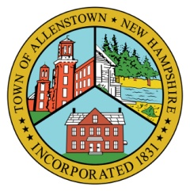 | Town of Allenstown  16 School Street  Allenstown, NH 03275  603-485-4276 | 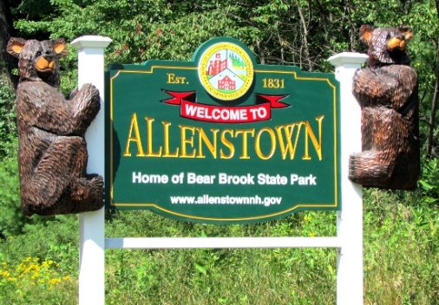

Video Conference, Wedsnesday, 6:30 p.m., January 27, 2021
Allenstown Town Hall, 16 School Street, Allenstown, NH
Join the meeting using the instructions posted online with this agenda.
Regular Business. Agenda items must be submitted to the Chairman by Weds. Noon before the meeting.
Pledge & Roll Call
Old Business
- Veteran's Suicide Awareness: Matt Seiler presented a proposal to the selectmen on Jan. 25th to display 660 flags on the town hall lawn. Discuss the outcome.
- Inspect Welcome banners: Inspect the recently received banners and hardware.
New Business
- 2021 Projects: Review the list and decide on which ones to work on. Create a schedule of dates.
Review Previous Meeting Minutes
Review and approve Dec. 10, 2020 minutes.
Schedule the next meeting
Plan on meeting Weds. February 10th.

Notices Regarding the Conduct of the Meeting.
  - Meetings are electronically recorded for the purpose of preparing written minutes. A record of the meeting is available for public inspection not later than five (5) business days after the meeting, as required by RSA 91-A:2, II. If you require accommodations under the Americans with Disabilities Act of 1990 (as amended), please contact the Town Administrator by telephone (603-485-4276 ext. 112) or send e-mail to ta@allenstownnh.gov. The EDC reserves the right to hold any non-public session during the Regular Meeting, whether noted on the Agenda or not. Notice of a non- public session on an agenda is for planning purposes only. The citations to the Right-to-Know Law, set out at NH RSA 91-A, are provisional and may be revised as circumstances require.

