TOWN OF ALLENSTOWN
Budget Committee Meeting Minutes
Community Center – Whitten Street
Allenstown, New Hampshire 03275
November 5, 2022

Call to Order

The Allenstown Municipal Budget Committee Meeting of November 5, 2022 was called to order at 9:01 am by Chair Boisvert.

Chair Boisvert led the Pledge of Allegiance.
Roll Call
Present on the Board: Chair Melaine Boisvert, Julie Keane, Carol Angowski, Mike Juranty, Deb Carney, Sandy Lambert, Bobbie LaFlamme, Jeff Venegas, Diane Adinolfo, John Childs, Keith Klawes, Selectboard Representative, Kris Bellerose, School Board Representative
Allenstown Staff: Derik Goodine, Town Administrator, Sherry Miller, Finance Director, Beth Tower, Allenstown Police Department, Mike Stark, Chief of Police, Scott McDonald, Selectboard, Mr. and Mrs. Armand Verville
Late: Chris Gamache and David Jodoin from Tri-Town, Maureen Higham
- BUDGET PRESENTATIONS

- POLICE DEPARTMENT
Chief Stark said there have not been major changes, so they will just discuss the highpoints. A copy of the budget as presented:
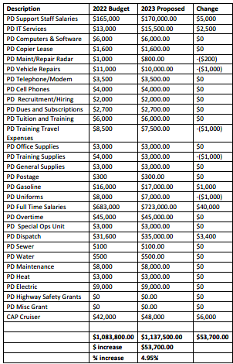
Chief Stark said the cost of doing business is going up and so they have had step increases. He said this is one of the best things that has ever happened to the Department and it is remarkably more expensive to replace employees than it is to keep them. This line item is where the biggest increase will be found (full-time salaries) as well as the support staff salaries.
Chief Stark said the next increase is with regard IT services, which will actually be across all of the Town budgets. The good news is that they will soon be resilient against any sort of ransom attacks.
The other lines that increased are dispatch and CAP Cruiser (vehicles).
Chief Stark answered questions from the Board. Ms. Angowski inquired regarding the police vehicles and SUVs. She also asked how many police officers do they have to which Chief Stark responded they have 10 full-time officers. He said they have one full time clerical workers, two part-time and a full-time prosecutor.
Chief Stark spoke to the difficulty of hiring police officers these days. He said they have a bonus plan in place for certified officers and in general salaries are going up across the state.
Chief Stark said a high school student could take classes through CRTC (includes Pembroke Academy) or an Explorer program and follow-up from there. He said the program attendance has slowed down due to Covid but seems to be ramping back-up.
He mentioned they just received their body cams which was paid in half through a grant and so far it has been a success. He said they also were able to purchase two OHRV to be used in Bear Brook and a drone that includes training.
Chief Stark said he envisions in the Spring applying for a grant to potentially fund an School Resource Officer for the new school and hire another officer based on the population growth that they know will be coming. He said their calls for service and crimes are going to go up.
Ms. Bellerose asked about the COPS program that he mentioned for an SRO, because when they looked into hiring a SRO, it was a significant jump in the school budget. He said it is not exclusive to just SROs and the conversation of how it would get funded 5 years from now would still need to happen. On the police side, it’s a win/ win.
Ms. Angowski asked if there was a DARE program. Chief Stark said there is not because of time and money. He said there have been a number of studies that show drug education is not super effective but he is not at all against it. He said it helps if they have a positive role model.
The Board had further questions regarding the drone use, batteries, video storage, etc.
Ms. Angowski said that she thought the Police Department Budget was in a good place.
Chair Boisvert asked if the Police Department has a wish list. He said yes, but right now he is most concerned about taking care of the officers. He doesn’t want unhappy employees and they need to stay competitive.
Chief Stark said he is putting in a grant for ballistic shields that are Kevlar but with a non-ricochet coating for every car ($600 to $3,000). He said they are also looking to get everyone a rifle.
Chief Stark said he would like to create Officer Wellness binders that sums up their training for both the officer and their significant others. He said he also wants his officers to talk to a financial advisor.
Chair Boisvert thanked Chief Stark for his time.
- TRI-TOWN AMBULANCE
Mr. Gamache said he is sure that everyone in the room is aware that Allenstown wants to terminate the agreement with Tri-Town Ambulance and Pembroke as it pertains to ambulance coverage. He said he is not there to criticize their ambulance proposal but he will say that they did go through the proposal and found some issues and discrepancies which will be mentioned as they are applicable to their 2023 budget.
He said their largest increase in their 2023 budget is the second ambulance that has already taken effect. [Link to the TTEMS Budget information can be found here: https://www.allenstownnh.gov/budget-committee/agenda/budget-committee-meeting-11-05-2022]
He said part of the talks between the two towns have been regarding the amount of calls they have given up to mutual aid as their call volumes rose. He said they provide more mutual aid but they also require more mutual aid.
Mr. Gamache said 2021 was the busiest year for the service and 2022 is looking to be over 100 more runs than 2021. He said currently they have given up about 126 runs to mutual aid.
In the past, they were looking at ways to get a second ambulance which they currently have. They have a primary ambulance and a 2nd which up until September was used for details, replacement when there were maintenance issues, etc.
Mr. Gamache said in reference to the first page of Chief Lambert’s proposal, he states that he and Chief Lambert did meet last fall and they talked about an ambulance proposal that was set forth by the Allenstown Fire Department 10 years ago and why it didn’t work, etc. Mr. Gamache said he mentioned what they did in the past to service the public and said at first that worked out really well however, as time went on, it became an unreliable plan.
Mr. Klawes asked how this was a part of the budget discussion and Mr. Gamache said it relates to the second ambulance.
Mr. Gamache said they started to move forward and then the Board of Directors came out and said that they wanted a demand analysis. The more calls they give up, the less they are serving the public. The demand analysis was presented to the Board of Directors in March of 2022 (which is equal representation between the two towns), and in May, he was asked to create a plan. Mr. Gamache said in June, Chief Lambert began to ask questions about the plan to present to Allenstown Board of Selectman.
Mr. Gamache said the plan was discussed and put into the budget for 2023 and it was ultimately approved in September. He said in October, after the request for dissolution came in from Allenstown, the plan still remained in the revised Pembroke TTEMS budget which is front of them now.
He described the costs related to the second ambulance which was $140,062 and the Town of Allenstown would be responsible for $64,720. He said they looked at the finances, and the cost for what is in the budget was accepted by the BOD and was going to be all inclusive (salaries, pay roll fees, and everything else that was going to be associated with the running of the 2nd truck.) This truck would run 10 hours a day, 7 days a week. Of the $140,062, their estimated revenues are $116,500 which leaves an operational difference of $23,562.00.
Mr. Gamache said in the past budgets, they budgeted for people to be on call and for details. Part of the plan that was presented to the Board was that second ambulance was now going to be used to cover details and they will no longer have people on call. The net difference to the cost of the two towns collectively for a second ambulance is $8,562. He said if you break that down, the $64,000 that was presented in his proposal was in reality $4,178 (actual cost for Allenstown).
He said what they discussed at the Board meeting was to use money that they have in an Unspecified Fund Balance so there is no risk to either town for funding the second ambulance. They do not yet know what Hillsbrook is actually going to use for call volume. Mr. Gamache said his numbers and Chief Lambert’s number are very much “off” but the reality is that nobody really knows.
Chair Boisvert asked how his numbers differ from Chief Lambert. Mr. Gamache said that there is no revenue to what he reported.
Mr. Gamache said he balances revenue with expenditures based on history. He said this year, they are looking at about $40,000 to $45,000 over budget and on the revenue side, and that is a good thing. He said when he looked at next year’s budget, a $60,000 increase is pretty realistic and then with Hillsbrook coming online.
He briefly spoke about Hillsbrook and the projected calls related to facilities similar to Hillsbrook which supports his reasoning that the $60,000 increase is a very safe number to go with.
Ms. Angowski asked questions regarding the number of full-time/ per diem employee salaries as it pertains to their schedule, budget and coverage. She asked if Tri-Town can do transport to which Mr. Gamache answered yes.
Chair Boisvert asked for clarification on the full-time salary line and asked if everyone (between combination of COLA and Merit increases) would be getting a 7.4% raise? He said correct.
Mr. Gamache discussed paramedic based service that is offered in conjunction with Pembroke which he said provides special services such as rapid sequence intubation. He said they are a municipality that does not compete with Fire Departments.
Mr. Klawes asked questions regarding dispatch. Mr. Gamache said that while Chief Lambert is saying that his staff responding to 80% of calls after hours and weekends, his staff is saying they are not. He said in his prior experience, Allenstown would not respond after 6-7 pm on a regular basis.
Ms. Bellerose asked what this is going to look like in 2025 when the contract is complete. Mr. Gamache said if there is a call for mutual aid, someone is going to respond whether it is Allenstown. Pembroke, Concord, Hooksett, Bow, Epsom. He said today, in 2022, 2023, 2024 they are a contracted ambulance service for both towns. He said if there is a call that they are not available for, automatically, fire dispatches mutual aid.
Chief Lambert said Allenstown will be certified for the paramedic level when the time comes. He said the Town is going to grow significantly in the next several years and to provide that fire based EMS service and also the availability provide additional fire service.
Mr. Klawes said that the Board of Selectman took due diligence in looking at this and probably put 6+ hours minimum into looking at this and it was discussed for 8-9 months. He said that Tri-Town needs to propose and stick to their budget but not editorialize it because it is a done deal and they have purchased an ambulance that is on the way. Mr. Klawes suggested that for the Deliberative Session or Public Hearings that they just stick to the numbers for 2023.
Mr. Gamache said they have the revised budget. He said they aren’t going to make any major purchases in the next year. They aren’t going to put any money into the CIP. Also, they decreased the uniform and supply lines and increased the vehicle maintenance line because they are past due purchasing another ambulance.
He said another change the revised budget was a decrease of $80,899. The revised budget is in the amount of $1,110,234. He described the changes including giving everyone a market adjustment due to the fact that the cost of everything is going up. Mr. Gamache said they did a market adjustment, COLA increases and merit increases. The second ambulances they discussed was probably already included into the budget line.
With regard to the revenue portion, Mr. Gamache said that they projected a relatively safe number.
Their used fund balance was originally a smaller number because they didn’t have the knowns of Hillsbrook or know truly what the second ambulance was going to bring in. He said with the dissolution pending, they are just going to continue that forward. He said they will also use that money to drive down what both towns are responsible for 2023-2024 that way both towns can free up money or do what they can to get their ambulances up and running.
He said the fund balance needs to be increased to just over $300,000. He said they look at how many calls were in these towns over the last three years, add them up and come up with a number and subtract that from their budget to then calculate the fiscal responsibility of the two towns. He said from that, they take a percentage. In the last three years, Allenstown has had 48.8% of the runs in the past three years so of what is remaining, the fiscal responsibility for what is remaining for Allenstown in 2023 is $142,375. Which, because of the use of fund balance is decreased by $91,326.
Below is a copy of the Budget as provided the Town of Pembroke:
. 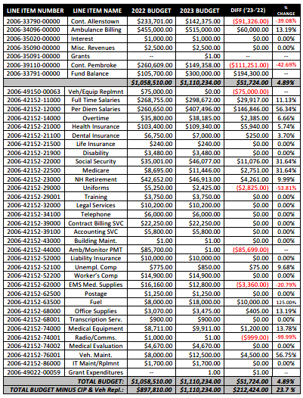
- OLD ALLENSTOWN MEETING HOUSE

Mr. Verville described the 200 year old property that is the Old Allenstown Meeting House. He said it is the town’s responsibilities for utilities and minor maintenance which is why they have a budget. He described the budget for 2023 as follows: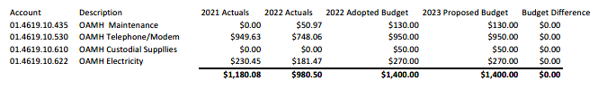
Ms. Angowski asked regarding the use of the building which Mr. Verville described in detail.

Ms. Bellerose asked if they have a Capital Trust Fund for the Meeting House in anticipation of a 200 year old building needing some improvements. Mr. Goodine said he doesn’t know that they have a reserve for it. Mr. Verville said they have never asked the town for a fund like that but they plan on the Historical Society, as long as it is healthy as it is right now, to handle major repairs. Should things change, the Town should look at making some sort of a trust fund.

Ms. Bellerose also asked if they have an interest and succession plan. Mr. Verville said they are desperately trying to get more members for the Historical Society and their dream would be to get some younger people to take over behind them.

Ms. Bellerose said that they were trying to have another School Board meeting in May and would like to have it at the Old Allenstown Meeting House.

The Board discussed the success of the bake sale. Mr. Goodine suggested they do a fundraising concert in Fall or Spring for the Old Allenstown Meeting House. Mr. Verville said the capacity of the Old Meeting House is 98 but grilling outside cannot happen.

- HIGHWAY DEPARTMENT
Mr. Pelissier said the first line item that has changed relates to electricity which is a $1,000 increase. He said that gas and diesel will also be a major increase and they will be paying market price.
He said the salary increases are part of the pay scale.
Mr. Goodine mentioned that they are conducting interviews for a support person to the Highway Department and she will also help Mr. Arsenault.
Chair Boisvert announced the arrival of lunch.
Ms. Bellerose said last year they were discussing staffing issues and turnover problems and wondered how it is going now. Mr. Pelissier said they had one turnover this year and he left making double. He said the workers they have now seem to be happy but the younger workers are harder to keep.
Mr. Pelissier said they have until June of 2024 for the contract with Casella and they will be discussing in the coming year, specifically with regard to recycling. He said their recycling is free but they do pay for trash.
Mr. Pelissier discussed the status of the new highway garage. He said the problem with the existing building is the size. He clarified that it is a brand new structure that they will be building.
As for vehicles, they have two large trucks (six wheelers), five 1-tons, and the old fire department pick-up truck.
Mr. Pelissier said that IT services has also gone up in price as well as winter sand and salt. He said in ice storms, they have to treat the town every four hours.
He said that equipment wise they are good. He said they have one older truck that he thinks they can use for a couple of more years. He said they do not use their bigger trucks a lot and in the past they have used them until the end of time. The problem with the newer trucks is the electronics and it worries him. He said their solution should be going on a quicker rotation and get good money out of them so it doesn’t cost them a lot to replace.
Chair Boisvert asked if they have a Master Plan in place for CIP purchases. Mr. Goodine said they do not really follow it yet because they can’t afford it.
She asked if they have a Capital Reserve for Equipment purchases. Mr. Pelissier said the truck is the biggest item but they are hoping the older truck will have another four years.
Mr. Pelissier said the paving line is $170,000 under Highway Construction Services. Mr. Goodine said they also have a Capital Reserve Fund. Mr. Pelissier said he would like to see Letendre, Bartlett, Ray Court and both the bridges get paved. He said sooner or later they are going to have to complete the Notre Dame project. He discussed the coordination that’s involved with both the water and sewer departments to get this done. He said they like to get the utilities updated before they do the work.
Chair Boisvert left the meeting and Mr. Venegas took over in her place.
The Board discussed the possibility of having new sidewalks for the new school and the costs involved. Ms. Bellerose commented that if it is not in the budget, then it is not something the DOE mandates.
Highway Department Budget:
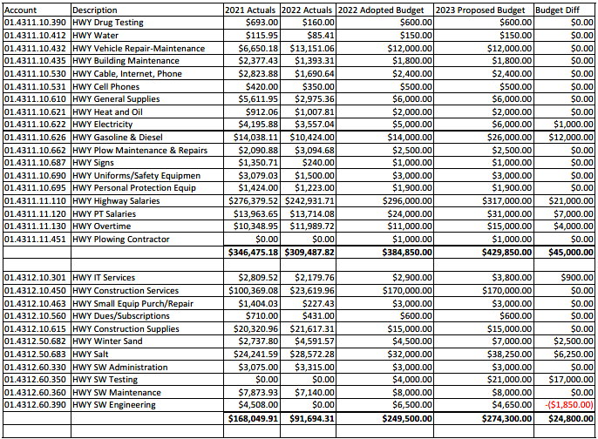
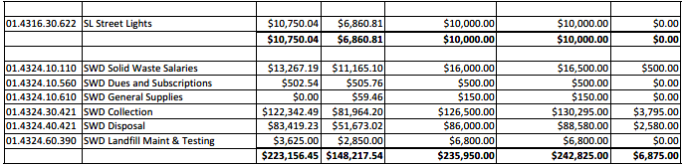

- TOWN CLERK AND FINANCE

Sherry Miller said there is an increase to Town Clerk and Tax Collector’s salary which is broken out percentage wise (step increase, COLA increase). The Finance Director’s salary is down a little as she did not come in at the same level as her predecessor. The budget also shows 1/5th of the Administrative Assistant’s salary that will soon be coming on board.

She said the election line item is down this year but next year it is going to go back up.

Ms. Miller also noted that another change is that they are only budgeting what the town actually pays for the audit. She said the only change for the accessing side, is the increase for the contracted service with Avitar.

Mr. Goodine added that they are going into a new contract with an IT provider and that line item will be going up but they have another $10,000 built into the budget this year that will be for cybersecurity items. He said there will be a server in the police department as well as Town Hall.

Ms. Pellisier described the Town Clerk, Tax Collector and Ballot Clerk positions.

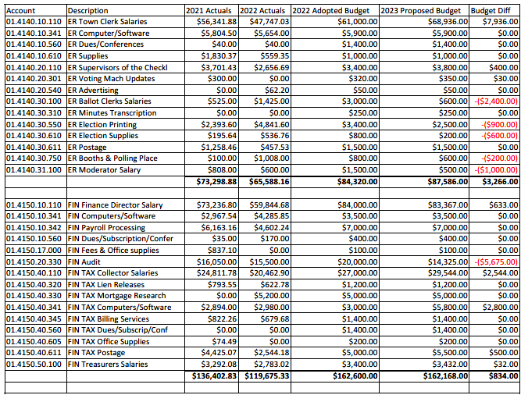

- LIBRARY

Mr. Venegas said the biggest change they have to the library budget is part-time salaries. He said they have two part-timers and an alternate who fills in when needed.

He said they also made adjustments to the line items for heat and electricity.

Mr. Venegas said there is a lot of things they want to do with the basement but they haven’t had a chance to do it yet. He said it is not handicap assessable which is a problem.

Before the pandemic, they were offering various opportunities to both the schools and seniors as the library is an important part of a small community. He said today they count on their everyday people coming in and word of mouth. They also offer Bear Brook park passes to the public.

Mr. Venegas said a project they are looking to do is create a community garden in the back of the library. Ms. Bellerose said there is also space behind AES.

He described the various summer programs the library offers which are gaining popularity. In addition, Ms. Randlett has been doing an amazing job each year obtaining grants. This year alone he said she received over $7,000 worth. He said they also use Amazon Smiles which they try to advertise to the public.

Ms. Pelissier said Ms. Randlett does such a good job with the summer reading program that it has attracted children from other towns. Mr. Venegas said there have been different themes and the children receive prizes for reading books. He said that in the past, Ms. Randlett has had a new weekly spice for cooking and also gardening/ outdoor kits for the children and presently they are transitioning to craft ideas for adults.

He said their numbers are close to being on par with pre-pandemic years, and they have 100 new patrons for this year.

Ms. Bellerose asked if the new China Mills residence will have a lobby area where they can post information relating to the activities in Town.
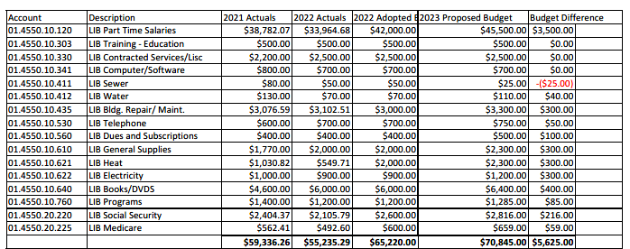
MOTION TO ADJOURN
Ms. Lambert made a Motion to adjourn 12:24. Ms. Bellerose seconded the Motion.
Roll Call vote was taken.
Melaine Boisvert, Aye Julie Keane, Aye Carol Angowski, Aye Mike Juranty, Aye Deb Carney, Aye Jeff Venegas, Aye Bobbie LaFlamme, Aye Sandy Lambert, Aye John Childs, Aye Kris Bellerose, Aye Diane Adinolfo, Aye
The Motion passed.

TOWN OF ALLENSTOWN
MUNICIPAL BUDGET COMMITTEE
PUBLIC MEETING MINUTES
November 5, 2022
Signature Page

Original Approval:
MELAINE BOISVERT, Chair | DATE
KEITH KLAWES, Selectboard Member | DATE
JULIE KEANE, Member | DATE
CAROL ANGOWSKI, Member | DATE
MIKE JURANTY, Member | DATE
JEFFREY VENEGAS, Member | DATE
DIANE ADINOLFO, Member
DEB CARNEY, Member | DATE
BOBBIE LAFLAMME, Member | DATE
KRIS BELLEROSE, School Board Member | DATE
SANDY LAMBERT, Member | DATE
JOHN CHILDS, Member | DATE

