TOWN OF ALLENSTOWN
Budget Committee Meeting Minutes
Community Center – Whitten Street
Allenstown, New Hampshire 03275
January 15, 2022
Call to Order

The Allenstown Municipal Budget Committee Meeting of January 15, 2022 was called to order at 8:01 am by Chair Boisvert.

Chair Boisvert led the Pledge of Allegiance.
Roll Call
Present on the Board: Chair Melaine Boisvert, Julie Keane, Carol Angowski, , Mike Juranty, Deb Carney, Matt Pitaro, Sandy Lambert, Bobbie Laflamme, Jeff Venegas
Allenstown Staff: Derik Goodine, Town Administrator; Debbie Bender, Finance Director; Keith Klawes, Selectboard Representative, Kris Raymond, School Board Representative
- Public Hearing Presentation
Chair Boisvert said they need to finalize a few things prior to the public hearing.
With regard to the school budget they approved at the last meeting, they need to add $161,810 to the budget bringing it to $12,110,949. She said the reason for the increase is the bond payment in which they thought they were just paying interest, but in 2023, they will be making a payment for first principal and interest.
Ms. Raymond said the bond sale happened on January 6th and that finalized everything. She said the interest rate is 2.16 for 20 years.
Ms. Raymond made a Motion to amend the school budget by increasing the number by $161,810, bringing the overall budget to $12,110, 949. Ms. Lambert seconded the Motion.
Roll Call vote was taken.

Melaine Bosivert, Aye
Julie Keane, Aye
Keith Klawes, Aye
Carol Angowski, Aye
Kris Raymond, Aye Mike Juranty, Aye
Deb Carney, Aye
Matt Pitaro, Aye
Jeff Venegas, Aye
Bobbie Laflamme, Aye
The Motion passed unanimously.
Ms. Angowski asked how much the tax rate would go up. Mr. Klawes said not much, but it is unknown.
Chair Boisvert said they have two Warrant Articles that they need to vote on.
She said Article 17 is the new Town Hall capital reserve fund for renovations of Allenstown Elementary School and to raise and appropriate the sum of $100,000 from the Unassigned Fund balance to be placed in this fund. The Board of Selectman will be agents to expend from this fund.
Ms. Keane made a Motion to put Article 17 on the table for discussion. Mike Juranty seconded the Motion.
Mr. Klawes said they have outgrown Town Hall and other communities will use a former school as a new Town Hall. This fund would be to pay for any minor repairs. Mr. Goodine said they may have Pre-K for the SAU to rent space in the building and potentially other small businesses. He described the additions and repairs he would like to make. He said the school will continue to be an emergency shelter and they will still have the baseball fields and the ability to have a community garden.
Mr. Goodine said next year they may discuss buying some of the land at ARD.
Mr. Goodine asked if they should switch Article 17 and 18 around so it makes more sense to the voters. Ms. Bender said you can’t put money in before you establish the Warrant Article. He asked if they should put the address down to make it more clear.
Mr. Pitaro asked what the plan was for the existing Town Hall. Mr. Goodine said they do not know.
Mr. Klawes said he would like to change the wording to just “renovation of Town Hall” or “Town Owned Building” in case it does not come to fruition. He said this would give them more flexibility.
Ms. Raymond said that Warrant Article 16 should stay because you want to keep adding to your maintenance fund and 17 is to establish renovation and 18 is to purchase it. Ms. Bender said they are reversing it, and 17 is the purchase with 18 the renovation.
Ms. Bender read Article 17 as “To see if the Town will vote and raise and appropriate sum of $1.00 for the purpose of purchasing Allenstown Elementary School at 30 Main Street, Allenstown, NH to be converted for use as the Town Hall and/or Community Center and Recreation and/or business space for lease.” Ms. Raymond said DRA will weigh in if this is not sufficient.
Ms. Angowski made a Motion to approve Article 17 as amended by Ms. Bender for potentially purchasing the AES at Main Street building. Ms. Carney seconded the Motion.
Roll Call vote was taken.
Melaine Boisvert, Aye
Julie Keane, Aye
Keith Klawes, Aye
Carol Angowski, Aye
Kris Raymond, Aye
Mike Juranty, Aye
Deb Carney, Aye
Jeff Venegas, Aye
Matt Pitaro, Nay
The Motion passed.
Ms. Bender read Article 18 as: “To see if the Town will vote to establish a Town Building Capital Reserve Fund under the provisions of RSA 35:1 for renovations of a Town owned building and to raise and appropriate the sum.”
The Boards discussed the language further.
Chair Boisvert read Article 18 as: “To see if the Town Hall will vote to establish a new Town Hall Capital Reserve Fund under the provisions of RSA 35:1 for renovations of Allenstown Elementary School and to raise and appropriate the sum of $100,000 of Unassigned Fund Balances to be placed in this fund. Further to name the Board of Selectman as Agents of to expend from such fun. ”
Mr. Juranty made a Motion to approve Article 18 as read by Chair Boisvert. Ms. Angoswski seconded the Motion.
Roll Call vote was taken.
Melaine Boisvert, Aye
Julie Keane, Aye
Keith Klawes, Aye
Carol Angowski, Aye
Kris Raymond, Aye
Mike Juranty, Aye
Deb Carney, Aye
Jeff Venegas, Aye
Matt Pitaro, Nay
The Motion passed.
With regard to Article 5, Mr. Goodine said that the default budget amount will change to $4,437,750.00. Chair Boisvert said the Article will read as follows, “The Town of Allenstown raise and appropriate as an operating budget not including appropriations by Special Warrant article and other appropriations voted separately, the amount set forth on the budget posted with the warrant or recommended by vote of the first session for the purposes set forth therein, totaling $4,501,630. Should this article be defeated, the default budget shall be $4,437,750 which is the same as last year with certain adjustments required by previous actions of the Town of Allenstown or by law. For the governing body to hold one special meeting according to RSA 40:13 X and XVI to take up the issues of a revised operating budget. Majority vote required.”
Mr. Pitaro made a Motion to approve Article 5 as read by Chair Boisvert. Mr. Juranty seconded the Motion.
Roll Call vote was taken.
Melaine Boisvert, Aye
Julie Keane, Aye
Keith Klawes, Aye
Carol Angowski, Aye
Kris Raymond, Aye
Mike Juranty, Aye
Deb Carney, Aye
Jeff Venegas, Aye
Matt Pitaro, Aye
The Motion passed.
Chair Boisvert read Article 2 regarding the school: “Should the Allenstown School District vote to raise and appropriate a sum of $83,000 in addition to the sum appropriated for personnel in the operating budget for the addition of a new teaching position at Allenstown Elementary School.”
Mr. Pitaro made a Motion to approve Article 2 as read by Chair Boisvert. Mr. Juranty seconded the Motion.
Roll Call vote was taken.
Melaine Boisvert, Aye
Julie Keane, Aye
Keith Klawes, Aye
Carol Angowski, Aye
Kris Raymond, Aye
Mike Juranty, Aye
Deb Carney, Aye
Jeff Venegas, Aye
Matt Pitaro, Aye.
The Motion passed.
Chair Boisvert said Article 3 is “Should the Allenstown School District vote to raise the appropriate sum of $50,000 to be added to the Special Education General Expendable Trust Fund previously established with such amount to be funded from the June 30, 2022 unassigned fund balance available to transfer on July 1, 2022. No amount will be raised from fiscal year 2022 – 2023 taxation.”
Ms. Angowski made a Motion to approve Article 3 as read by Chair Boisvert. Ms. Keane seconded the Motion.

Melaine Boisvert, Aye
Julie Keane, Aye
Keith Klawes, Aye
Carol Angowski, Aye
Kris Raymond, Aye
Mike Juranty, Aye
Deb Carney, Aye
Jeff Venegas, Aye
Matt Pitaro, Aye.
The Motion passed.
Ms. Angowski made a Motion to recess. ____ seconded the Motion.

Melaine Boisvert, Aye
Julie Keane, Aye
Keith Klawes, Aye
Carol Angowski, Aye
Kris Raymond, Aye
Mike Juranty, Aye
Deb Carney, Aye
Jeff Venegas, Aye
Matt Pitaro, Aye.
The Motion passed.
- PUBLIC MEETING
Chair Boisvert called the public meeting to Order at 9:10 am.

Chair Boisvert led the Pledge of Allegiance.
Roll call: Amber Wheeler, Finance Administrator for SAU, Peter Warburton, Superintendent, Michael Sacharko, Special Education Coordinator, Shannon Kreuger, Principal, Sarah Peterson, Assistant Principal.
The Budget Committee repeated their roll call for the public meeting.
Additional people in attendance are: Scott McDonald, Chad Pelissier, Jim Rodger, Mike Frascinella, Sandy McKenney, Claudette Verville, Armand Verville, Ryan Carter, Jeff Backman, Russ McMan, Mr. Gish, Michael Stark, Chief of Police
- Town Warrant Articles
Chair Boisvert is going to read out loud the Town Warrant Articles that have monetary value. [A copy of the Warrant Articles can also be found on the Town website at: https://www.allenstownnh.gov/2022-town-meeting-budget]
Chair Boisvert read Article 5, the town operating budget.
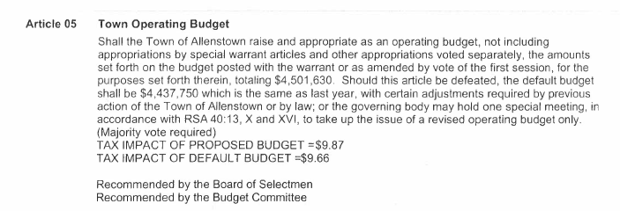
Chair Boisvert said the revenues that are expected for the Town next year will offset this.
Chair Boisvert read article 6, the Sewer Operating Budget.
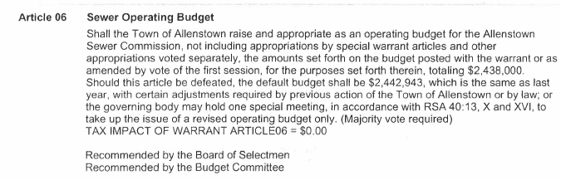
Chair Boisvert read Article 7, Library Cpaital Reserve Fund.
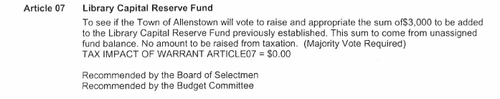
Chair Boisvert read Article 8, Public Safety Facilities Capital Reserve Fund.
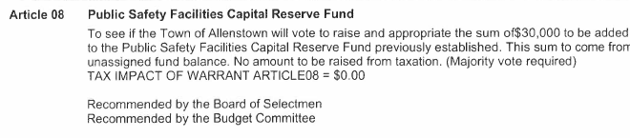
Chair Boisvert read Article 9, Highway Equipment Capital Reserve Fund.
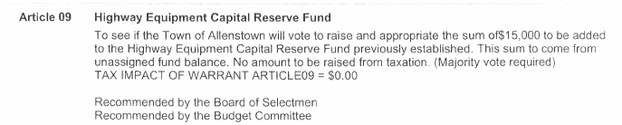
Chair Boisvert read Article 10, Economic Development Capital Reserve Fund.

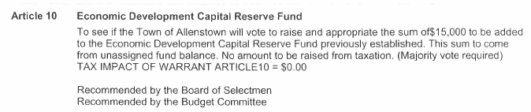
Mr. Frascinella thanked Chad Pelissier and members of the Highway Department and Ron Adinolfo for helping to recreate the Allenstown ice rink.
Chair Boisvert read Article 11, Assessing Valuation Update Capital Reserve Fund.
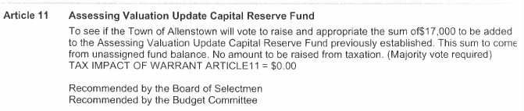
Mr. Goodine said they do not know what the tax impact will be as they do not know what the new valuation will be and that will be a determinant factor.
Chair Boisvert read Article 12, Parks & Recreation Projects Capital Reserve Fund.
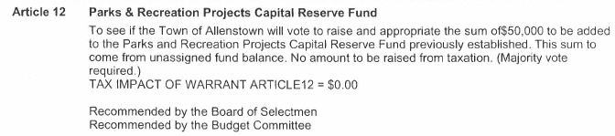
Chair Boisvert read Article 13, Road Repair and Paving CRF.
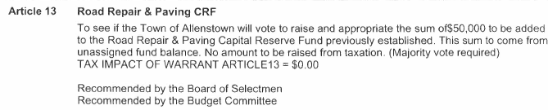
Chair Boisvert read Article 14, Highway Garage CRF.
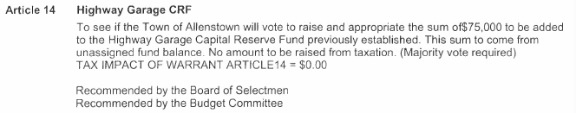
Chair Boisvert read Article 15, Fire Department Equipment.
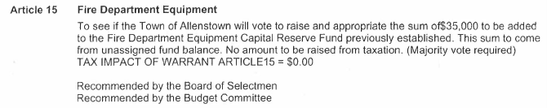
Chair Boisvert read Article 16, Town Building Maintenance Fund.
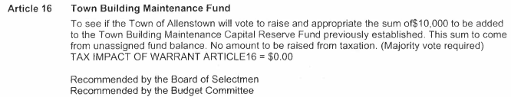
Ms. Bender read Article 17, Purchase of Allenstown Elementary School.
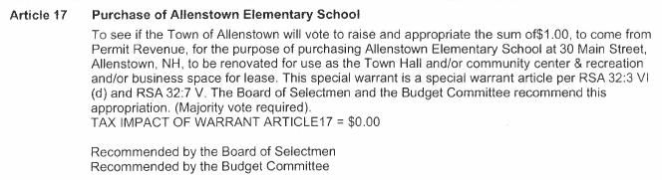

Ryan Carter had a question on the revaluation. He asked that with regard to the increases of the new school payment and increases in value, is it projected that the tax rate will go up automatically with no spending increases this year. Mr. Goodine said the Town portion should not got up, and they also used $309,000 to knock $1.03 off the tax rate for the Town. He said he would wait for the school session for a further answer. Mr. Klawes said that the State budget this year cut out funding for education so that factors into it in addition to the school building.
Ms. McKenney had concerns regarding the cost of refurbishing the school. Mr. Klawes said they just won’t know until it takes place. He said they also can’t predict what business will be interested.
Mr. Carter said the School District knew those funds mentioned by Mr. Klawes were going to go away. He also said why, if the school was deemed unfit for the children, but it’s okay for renovations for businesses and town offices. Mr. Goodine said the report said ARD had the issues and not AES.
Mr. Carter asked if they knew how much it was going to cost to run the building with water, sewer, electric and heat. Mr. Goodine said he thought it was going to be averaging around $30,000 depending on the year.
Mr. Carter asked why couldn’t they just sell it and bring the money back to the taxpayers.
Mr. Gish asked why Allenstown’s tax rate is so high. Chair Raymond said it has always been this way. Mr. Goodine said 50% of the town is owned by the State which limits their ability to develop, and the state needs to do a better job of giving subsidy to the districts that need it. Mr. Carter said building a new school is not going to help the tax rate. Chair Boisvert said that it’s a state issue, not a school budget issue. Mr. Klawes said the town citizens need to contact their state representative.
Mr. Carter asked what were the dollar values for the town from 2016 forward. Mr. Goodine said it’s laid out in the budget overview. Chair Boisvert said it’s important to know that the school gives back surplus to the Town to offset tax rates.
Ms. Bender read article 18, New Town Hall Renovation CFR.
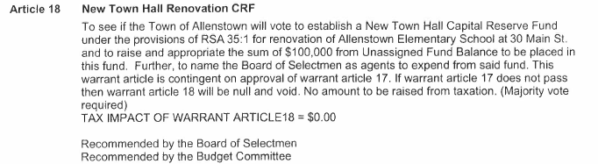
Mr. Goodine said the Census is in and from 2010 to 2020, they gained about 350 new residents. He said by 2024, they will probably have an additional 400 new residents due to senior living and the development at the mills. He said that the Town Hall they have now is not large enough to accommodate a growing population. He said if they were to build, it would cost significantly more with purchase of the land, materials and builders.
Mr. Carter asked if they could consolidate the AES space with the Police Department. Mr. Goodine said any option could be on the table. Mr. McDonald said that is a possibility that has been discussed. Mr. Klawes said his only concern would be if that were to deter other companies from sharing that space.
- School Warrant Articles
A copy of the Warrant Articles can also be found on the Town website at: https://www.allenstownnh.gov/2022-town-meeting-budget]
Chair Boisvert read Article 1 relating to the Operating Budget.
Shall the Allenstown School District vote to raise and appropriate as an operating budget, not including appropriations by special warrant article and other appropriations voted separately, the amounts set forth on the budget posted with the warrant or as amended by vote of the first session, for the purposes set forth therein, totaling, $12,110,949. Should this article be defeated, the operating budget shall be $12,058,435 which is the same as last year, with certain adjustments required by previous action of the Allenstown School District, or by law, or the governing body may hold one special meeting in accordance with RSA 40:13, X and XVI, to take up the issue of a revised operating budget only.
Chair Boisvert read Article 2 relating to an additional teacher.
Shall the Allenstown School District vote to raise and appropriate the sum of $83,000 in addition to the sum for personnel in the operating budget for the addition of a new teaching position in the Allenstown Elementary School. The School Board recommends approval. The Budget Committee recommends approval.
Chair Boisvert read Article 3 relating to the Special Education Trust Fund.
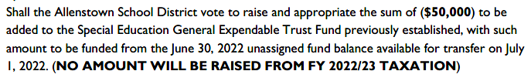
Chair Raymond introduced the School Board and notes they have an open School Board position on the ballot. She said they have 5 trust funds and they decided to only add to the Special Education Trust Fund. This is to be used if a new student moves to the district and needs services.
She said Warrant Article 4 is to adopt the new regulations pertaining to Fund Balance Retention. She said retainage is the for purpose of having funds on hand for emergency expenditures. She said unused retainage goes back to the taxpayers, but the new regulations said that they can keep 5%.
Chair Raymond said that the default budget for the 2022-2023 fiscal year is $12,058,435. The School Board’s proposed budget is $12,110,949, with the difference being $52,514. She said the prior year voted was $12,007,385 and the change between prior year voted is $103,564.
She discussed student demographics- which is 505 students total.
Chair Raymond said special education is under both federal and state mandates. She said the student population is about 126 students, which is consistent with last year.
She discussed personnel related costs and monies going to other districts. They added 3 special education paraprofessionals.
With regard to the new teacher add in Warrant 2, she said they have seen a kindergarten uptick since 2016 and the trend is not going down.
She said that health and dental has both gone up, as well as tuition to Pembroke Academy.
Chair Raymond said the projected taxes for the school budget is showing an increase of $3.31. She said this number is historically higher than what comes out as actual.
She said showed the source of revenue funds for the past 5 years.
Mr. Carter said they knew they had a time limit on that funding from the state, and they included it in the budget. He asked whether it’s time to take a hard look at the budget, and cut out approximately $500,000. Chair Raymond said aside from personnel, which you are contractually obligated to expend, there is no place you can elimiate $500K from the school budget.
Mr. Carter asked how much did the school get in Covid funding this year. Chair Raymond said that ESSER relief monies is broken out into when they would have given the grants. She said there were four different iterations in the amounts. The first installment was $152,000 in 2020; in 2020, there was a second round in the amount of $103,800. She said that had to be spent by December 31, 2021. ESSER 2 came around and they received $795,990 which has to be spent by 2023. The last is ESSER 3, and they received $1,787,680 which has to be spent by 2024. Chair Raymond said they have to spend it according to how the grant specifies.
Mr. Sacharko said he also manages the grants for the district. He said the grants have to be spent on things related to Covid which could be PPE supplies, sanitation. It also could be spent on items related to learning loss and they can also use it on technology.
Mr. Sarcharko said they have spent the most money on technology, cleaning, PPE and also for the temporary positions for behavioral staff.
Mr. Carter said in looking at the school proposed budget for last year and this year, there is a $1.3 million increase. Chair Raymond said that she did not agree with the number he is using for the previous year and that he was looking at a number from 2 years ago. She said she could not give him an exact answer regarding the differences at the moment because he is not incorporating the warrant articles. Chair Boisvert said that they are also including in this year’s budget the debt service for the new school.
Chair Boisvert told Mr. Carter that they cannot use the Covid funding for the operation of the schools.
Mr. Carter asked if they could rearrange the current teachers in order that they do not need to hire a new teacher. Chair Raymond said the number he is looking at from prior years also includes Pembroke Academy students. She said they currently have to rehire staff after someone retires, whereas in 2016 they did not have to.
Mr. Pitaro said there will be four open positions on the Budget Committee. Mr. Klawes said there will be two open Selectman positions open as well.
Chair Boisvert thanked the School Administration for their joining them.
Mr. Angowski made a Motion to adjourn. Mr. Juranty seconded the Motion.
Roll call vote was taken.
Melaine Boisvert, Aye
Julie Keane, Aye
Keith Klawes, Aye
Carol Angowski, Aye
Kris Raymond, Aye
Mike Juranty, Aye
Deb Carney, Aye
Jeff Venegas, Aye
Matt Pitaro, Aye.
The Motion passed.
The Motion to adjourn was rescinded.
Mr. Venegas made a Motion to approve and sign the MS 737 that will be prepared by Deb Carney. Ms. Angowski seconded the Motion.
Roll call vote was taken.
Melaine Boisvert, Aye
Julie Keane, Aye
Keith Klawes, Aye
Carol Angowski, Aye
Kris Raymond, Aye
Mike Juranty, Aye
Deb Carney, Aye
Jeff Venegas, Aye
Matt Pitaro, Aye.
The Motion passed.
Mr. Pitaro made a Motion to adjourn at 10:50 am. Mr. Venegas seconded the Motion.
Roll call vote was taken.
Melaine Boisvert, Aye
Julie Keane, Aye
Keith Klawes, Aye
Carol Angowski, Aye
Kris Raymond, Aye
Mike Juranty, Aye
Deb Carney, Aye
Jeff Venegas, Aye
Matt Pitaro, Aye.
The Motion passed.

TOWN OF ALLENSTOWN
MUNICIPAL BUDGET COMMITTEE
PUBLIC MEETING MINUTES
January 15, 2022
Signature Page

Original Approval:
MELAINE BOISVERT, Chair | DATE
KEITH KLAWES, Member | DATE
JULIE KEANE, Member | DATE
CAROL ANGOWSKI, Member | DATE
MIKE JURANTY, Member | DATE
JEFFREY VENEGAS, Member | DATE
DEB CARNEY, Member | DATE
BOBBIE LAFLAMME, Member | DATE
KRIS RAYMOND, Member | DATE
SANDY LAMBERT, Member | DATE

