Town of Allenstown
Board of Selectmen
16 School Street
Allenstown, NH 03275
603-485-4276 ext. 112
TA@allenstownnh.gov

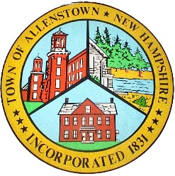

RESOLUTION

WHEREAS, The Town of Allenstown contracts with Nobis Engineering in order to manage the Town’s Annual Groundwater Management Program at the Allenstown Landfill as directed by the NH Department of Environmental Services.

WHEREAS, That project is complete and should be paid for with funds from the Landfill Capital Reserve Fund. As such, the board requests that the Trustees of the Trust Funds transfer $3,500.00 from the Landfill Capital Reserve Fund to the Town for deposit to the General Fund cash 01-1010-10.

WHEREAS, the expense code 07-4915-10-910 for Landfill CRF, will be used to pay for the Nobis Engineering Invoice #0024822 in the amount of $3,500.00.

On this 12th day of March this resolution is approved by the Board of Selectmen.

Board of Selectmen

__________________________
Jason Tardiff, Chairman

__________________________
David Eaton, Selectmen

__________________________
Ryan Carter, Selectmen

I hereby certify a vote was taken by the Board of Selectmen on 3/12/2018 in the affirmative to approve this resolution.

__________________________
Michael Stark, Town Administrator

