Town of Allenstown
Board of Selectmen
16 School Street
Allenstown, NH 03275
603-485-4276 ext. 112
TA@allenstownnh.gov

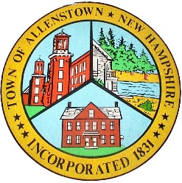

RESOLUTION

At a duly called meeting of the Allenstown Board of Selectmen held on March 12, 2018 the following resolution was introduced and adopted:

BE IT RESOLVED by the Governing Body of Lessee as follows:

1. Determination of Need. The Governing Body of Lessee has determined that a true and very real need exists for the acquisition of the Equipment described on Exhibit A of Schedule No. 09 (a 2018 Ford Police Interceptor, SUV) dated as of March 12, 2018 to the Master Lease Purchase Agreement dated as of April 15, 2013, between Town of Allenstown (Lessee) and Tax-Exempt Leasing Corp. (Lessor).

2. Approval and Authorization. The Governing Body of Lessee has determined that the Agreement and Schedule, substantially in the form presented to this meeting, are in the best interests of the Lessee for the acquisition of such Equipment, and the Governing Body hereby approves the entering into of the Agreement and Schedule by the Lessee and hereby designates and authorizes the following person to execute and deliver the Agreement and Schedule on Lessee’s behalf with such changes thereto as such person deems appropriate, and any related documents, including any Escrow Agreement, necessary to the consummation of the transaction contemplated by the Agreement and Schedule.

Authorized Individual: Michael Stark, Town Administrator

On this 12th day of March this resolution is approved by the Board of Selectmen.

Board of Selectmen

__________________________
Jason Tardiff, Chairman

__________________________
David Eaton, Selectmen

__________________________
Ryan Carter, Selectmen

I hereby certify a vote was taken by the Board of Selectmen on 3/12/2018 in the affirmative to approve this resolution.

__________________________
Michael Stark, Town Administrator

