2016 Budget
Submitted by
Chief Paul Paquette

Allenstown

Police
Department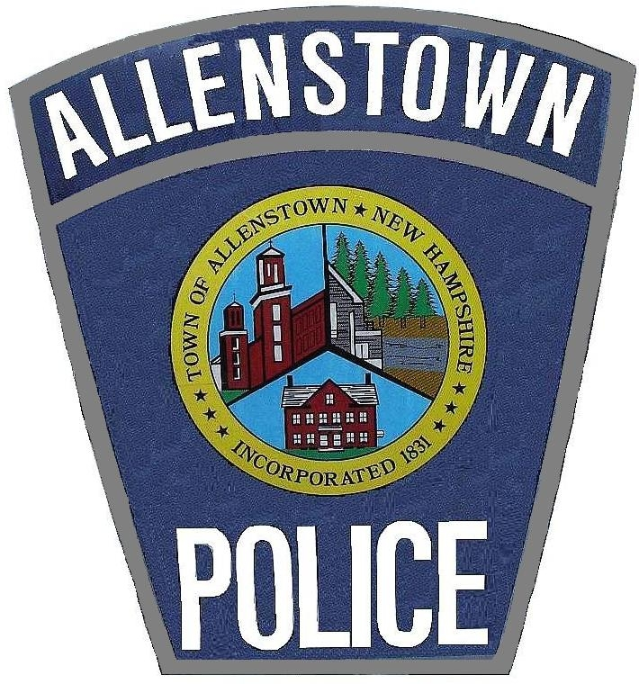

TABLE OF CONTENTS

- Police Dept. Budget Spreadsheet Page 3
- Revenue Projection Spreadsheet Page 5
- Mission, Vision , and Values Statement Page 6
- Introduction Page 7
- Outlook of the Five Year Operations Plan Page 10
- Capital Improvements Plan Page 11
- Budget Line Items Page 12
- Grants/Cooperative Efforts Page 21
- Statistics Page 22
- Salary Reference Chart Page 38
- Animal Control Budget Page 39

 |  | 2014 | 2014 | 2015 | 2016 | 2016 | Dept. %
Account Number | Account Name | Budget | Actual | Budget | Default | DEPT. | Increase
General Fund (1) |  |  |  |  |  | Requested
1-4210.10-110 | PD Support Staff Salaries | 124,892 | 128,392 | 132,671 | 132,671 | 136,693 | 3.0%
1-4210.10-131 | PD Training Overtime | 12,150 | 9,302 | 10,150 | 10,150 | 6,400 | -36.9%
1-4210.10-301 | PD IT Services | 8,606 | 8,755 | 8,606 | 8,726 | 8,726 | 1.4%
1-4210.10-341 | PD Computer/Software | 6,606 | 9,354 | 6,606 | 6,606 | 4,606 | -30.3%
1-4210.10-430 | PD Copier Lease | 3,000 | 1,970 | 3,000 | 2,000 | 2,000 | -33.3%
1-4210.10-431 | PD Maint/Repair Radar | 2,500 | 530 | 2,500 | 2,500 | 1,500 | -40.0%
1-4210.10-432 | PD Vehicle Repairs | 13,000 | 7,734 | 13,000 | 13,000 | 11,000 | -15.4%
1-4210.10-530 | PD Telephone/Modem | 3,610 | 2,805 | 4,054 | 4,054 | 5,054 | 24.7%
1-4210.10-531 | PD Cell Phones | 5,690 | 4,334 | 5,690 | 5,690 | 5,690 | 0.0%
1-4210.10-550 | PD Recruitment/Hiring | 2,000 | 2,766 | 2,000 | 2,000 | 2,000 | 0.0%
1-4210.10-560 | PD Dues and Subscriptions | 2,000 | 1,281 | 2,000 | 2,000 | 2,000 | 0.0%
1-4210.10-580 | PD Tuition and Training | 3,951 | 6,358 | 3,951 | 3,951 | 3,451 | -12.7%
1-4210.10-605 | PD Office Supplies | 4,875 | 6,713 | 6,500 | 6,500 | 5,500 | -15.4%
1-4210.10-606 | PD Training Supplies | 4,451 | 889 | 4,451 | 4,451 | 3,500 | -21.4%
1-4210.10-610 | PD General Supplies | 1,625 | 2,368 | 1,625 | 1,625 | 1,625 | 0.0%
1-4210.10-611 | PD Postage | 600 | 329 | 600 | 600 | 600 | 0.0%
1-4210.10-626 | PD Gasoline | 36,288 | 22,339 | 36,288 | 36,288 | 32,000 | -11.8%
1-4210.10-690 | PD Uniforms | 6,750 | 9,275 | 6,750 | 6,750 | 6,750 | 0.0%
1-4210.10-752 | PD Cruiser | 35,000 | 34,704 | 35,000 | 35,000 | 36,000 | 2.9%
1-4210.11-110 | PD Full Time Salaries | 519,787 | 472,594 | 542,864 | 542,864 | 515,076 | -5.1%
1-4210.11-130 | PD Overtime | 32,958 | 42,953 | 32,158 | 32,158 | 32,158 | 0.0%
1-4210.50-400 | PD Special Ops Unit | 3,000 | 3,000 | 3,000 | 3,000 | 3,000 | 0.0%
1-4210.50-531 | PD Dispatch | 31,200 | 24,430 | 29,200 | 29,200 | 27,200 | -6.8%
1-4210.60-411 | PD Sewer | 150 | 76 | 150 | 150 | 150 | 0.0%
1-4210.60-412 | PD Water | 650 | 544 | 650 | 650 | 650 | 0.0%
1-4210.60-435 | PD Maintenance | 6,500 | 12,915 | 6,500 | 6,500 | 6,000 | -7.7%
1-4210.60-621 | PD Heat | 4,400 | 2,405 | 4,400 | 4,400 | 3,900 | -11.4%
1-4210.60-622 | PD Electric | 10,500 | 9,002 | 10,500 | 10,500 | 9,000 | -14.3%
1-4210.70-130 | PD Traffic Enforce Grant | 17,000 | 1,187 | 17,000 | 17,000 | 12,000 | -29.4%
1-4210.70-780 | PD Misc Grant | 1 | _________ | 1 | 1 | 1 | 0.0%
1-4210.70-810 | PD K9 Patrols | _________ | _________ | _________
**Total** POLICE |  | 903,740 | 829,304 | 931,865 | 930,985 | 884,230 | -5.1%

FY 2016 PROJECTED REVENUE
 | Account Name | FY 2013 | FY 2014 | FY 2015 | FY 2016
Department |  | Actual | Actual | Revenue to date | Projected
 |  | Revenue | Revenue | Revenue | Revenue
Police
 | Traffic Enforcement Grant | $ 7,414.12 | 1,331.58 | 0 | 4,000.00
 | Op. Safe Commute | $ 794.40 | 464.17 | 0 | 5,522.40
 | DUI Hunter/Patrols | $ 7,706.95 | 0 | 0 | 4,000.00
 | Misc PD Revenue | $ 338.00 |  | 0 | 0
 | Pistol Permits | $ 680.00 | 1,210.00 | 460.00 | 1,300.00
 | PD Income (rpt fees & parking fines) | $ 3,377.00 | 3,621.54 | 3,110.08 | 3,700.00
 | OHRV Grant | $ 720.00 | 0 | 0 | 0
 | Court Fines | $ 2,282.00 | 901.28 | 654.52 | 2,000.00
 | Under Age Alcohol TF | $ 240.00 | 0 | 0 | 0
 | Details | $ 2545.00 | 10,323 | 3,515.50 | 7,000.00
 | Warrant Service | $ 272.00 | 0 | 102.80 | 300
 | Sex Offender Reg. Fee | $ 0.00 | 0 | 40.00 | 40.00
 | Hawkers/Peddlers Fees | $ 180.00 | 220.00 | 0 | 100.00
 | Pawn Broker/2nd Hand Dlr | $ 0.00 | 0 | 0 | 100.00
 | Animal Control Fines | $ 465.00 | 50.00 | 305.00 | 400.00
Total |  | $ 27,015.24 |  | 28,850.00 | 23,200.00

ALLENSTOWN POLICE DEPARTMENT

MISSION, VISION, AND VALUES

MISSION STATEMENT

In cooperation with the people of Allenstown and in partnership with other public and private agencies, to assume a leadership role through a problem-solving approach to preventing crime and disorder, reducing citizen fear of crime, providing a variety of community policing services, provide traffic enforcement on the roadways to maintain safety and interacting and being visible within the community to improve the quality of life for citizens.

We will steadfastly uphold the constitution of the United States of America, the New Hampshire constitution and the laws of the State of New Hampshire. We will enforce the laws of the land and the ordinances of the Town of Allenstown.

VALUES STATEMENT

The Allenstown Police Department is committed to fulfilling its mission by upholding the following values:

SERVICE

We will strive to be responsive to the needs of the citizens of our community. Service to our citizens is a critical component of the foundation of what we do. Working cooperatively with the other departments of the town to enhance the quality of life in the community is essential.

INTEGRITY

We will adhere to the highest ethical standards and accept responsibility for our decisions and actions. We uphold and demonstrate moral behavior that is expected of a community’s police department.

RESPECT

We will treat all employees, offenders and the public with fairness, honesty, compassion, consideration and respect while recognizing individual diversity.

PROFESSIONALISM

We will be fair and consistent in the performance of our duties and responsibilities. As positive role models, we will take pride in maintaining the quality of our services through our performance, appearance and continued education and training. We will instill trust and teamwork by providing support to fellow employees and promoting cooperation and effective communication.

VISION

It is our vision that the Allenstown Police Department will continue to be a cornerstone of progress and a model police department in service to our citizens, caring for our employees, and constant improvement to the quality of the services that we render.

INTRODUCTION

This past year has been a very challenging year for the staff in our department. Unfortunately we continue to lose patrolmen at a high rate after they have been trained at the expense of the taxpayers. We are still trying to fill positions from last year. We will miss Det. Baker who served our department for the past five years. He was an excellent detective who made a huge impact in solving crimes in our town. The department was fortunate to hire Det. Sgt. Shea for the position. She brings a wealth of experience from the Merrimack, Pembroke and Bow police departments. Ptl. Wilcox who was hired in 2014 was deployed by the US Army to Dubai for one year. Prior to his deployment Ptl Wilcox did an excellent job for the department and we look forward to his safe return sometime in December after proudly serving our country.
Lt. Stark has done an excellent job in his first year as the Executive Officer for the department. He continues to take on new tasks even with the staffing shortages within the department and has to adjust his schedule on a monthly basis. He serves as the Deputy Emergency Director for the town and is also the head negotiator for the Central New Hampshire Special Operations Unit (SWAT) .
Sgt Tower has also finished her first year after being promoted to the Sergeant position. She has also done an excellent job in her new role. Sgt. Tower has revamped the Field Training Officer program, assumed the role of the department training program coordinator and has made several new changes to our department forms.
We welcome Officer Warburton, Officer Bowler, Officer Bowen and Officer Moreta. Officer Bowen and Officer Moreta will be attending the academy in late August.
We will greatly miss Prosecutor Alicia O’Rourke who did an outstanding job for us over the past five years. She is a prime example of a prosecutor who is truly dedicated to her job. Prosecutor Dorothy Walch has been hired as her replacement. Prosecutor Walch has been working with the Strafford County Attorney’s Office for the past seven years. She has vast experience as an Assistant County Attorney and we look forward to her bringing her expertise to the Town of Allenstown.
School Resource Officer Rebecca King has resigned as the SRO as of this past year. Officer King had been with the department for 9 years when she took the role of SRO. Officer King did an excellent job as SRO over the last 2 years but leaving law enforcement to pursue a career in teaching. Officer Poppalardo was hired for the position of SRO. SRO Poppalardo has 7 years of experience as an SRO while being employed in Florida.

I cannot say enough about our department’s administrative staff. Administrative Assistant Dawn Chabot and evening Administrative Assistant Cheryl Hey do such an amazing job in trying to keep up with the department’s daily administrative tasks, some of which include: the processing of license to carry applications, assisting the Prosecutor by sending out discovery and outputting subpoenas for court cases, the processing of purchase orders & check requests (accounts payable & receivable), maintaining department employment files & rosters, processing paperwork for police service to and from other agencies, assisting other departments by facilitating the sharing information and serving as the records department by releasing accident and police reports in accordance with the right to know law. Most importantly, Dawn and Cheryl are often the first and only face of the police department that many citizens see and both go above and beyond to assists all citizens in a kind, courteous manner.
Retention of new officers remains an issue within the department. We are able to hire officers at a competitive starting salary but are unable to retain them due to lack of a wage classification system. Surrounding towns have wage classification systems and union contracts which are attractive to young officers who we continue to train. In 2016 we are facing more cuts to keep your tax rate down. The select board continues to try and keep the tax rate down but it will be a direct impact on services within the town.

This year all department heads were given a directive to reduce our budgets by 5%. Within the police department this amounts to $49,000. In order to meet this 5 % it we have to reduce the staff by one officer. With the layoff of a police officer, reducing the training line and the overtime line, which has been exhausted over the past several years due to the retention of officers. This will impact the new officers who need continued training. The loss of the police officer’s position will affect midnight coverage starting January 1, 2016. We currently have one officer deployed overseas and two officers in the academy. This causes very low staffing levels which will not allow for shift coverage two nights a week when we are at the lowest.

.

We will continue to implement a comprehensive strategic plan to reduce criminal activity in the community. However, this year we have seen an decrease in traffic accidents, arrests and criminal incidents. The statistical chart below shows data for a 12 month period.
 | 8/2014-8/2015 | 8/2013-8/2014 | 8/2012-8/2013
Arrests | 226 | 187 | 224
Accidents | 67 | 72 | 82
Criminal Incidents | 405 | 358 | 592
Calls for Service | 6,051 | 6,456 (11,298 Disp) | 6053 (12,528Disp)
Citations | 1,464 | 1,375 | 1,699

As always I look forward to working with the Board of Selectmen, the Budget Committee and the other departments of the town to enhance the quality of life in Allenstown.
IDENTIFIED CRITICAL AREAS
.
The police department still struggles with retention of qualified, experienced personnel at the patrol officer level. Once again this past year we have lost several personnel to the following area agencies; Hooksett, Franklin, Bedford, and Manchester. As you can see we lose the majority of our personnel to larger police departments that generally have a base entry salary of five to ten thousand dollars more per year than we offer. We have been able to hire good candidates for the entry level positions. We continue to have difficulty in retaining seasoned officers. In 2014 and 2015 we have been able to give COLA raises and a small merit raise for some personnel. The normal authorization for the department is six patrol officers, this past year we have been reduced to two patrol officers while trying to hire new officers. The three supervisors and I have been working on patrol which takes us away from our normal duties.

We provide the funding to invest in the training of the officer which includes the recruit academy which has increased to 16 weeks. The Field Training Program (12 to 14 weeks), in-service training which depends on the length of time they stay with us. New Hampshire is unique among most of the other states in that we have one police academy which serves all local, county and state law enforcement agencies. The Police Standards and Training Council (PSTC) is completely funded through a penalty assessment on fines for motor vehicle and criminal offenses. There are no tax revenues used to fund the academy. In other states local communities pay a fee to send an officer to the academy as well as to attend in service courses throughout their career. This year all police departments were notified that PSTC will be unable to fund outside training. This means the costs for training will be increased for each department. We are now forced to send officers to outside training at our expense.

COST OF HIRING A NEW OFFICER
Recruit Academy (salary) | $14,687
Field Training Program (salary) | $13,115
In-Service Training (salary) | $3,000
Uniforms (with vest) | $2,400
Ammunition | $1000
Testing | $1,200
Total | $35,402

b. A seasoned officer generally has three to five years’ experience. We have lost most of our officers between years two and three. During the first and second year officers are learning the job and making the mistakes that they will learn from to make them seasoned officers. We continue to stay in this status. We are continually spending large amounts of money that we get nothing back from. The other communities are reaping the benefits of our investments. In 2015 we lost two officers, two to the private sector and another to a similar department that has advancement opportunities and annual pay increases. As we have fallen behind again we have found ourselves in the position we were in before in regards to retention of experienced personnel. When we lose officers at these high rates it takes over a full year before we are able to have officers on the street to replace the ones that have left.

c. Financial crimes such as identity fraud, credit card fraud, computer crime and drug crimes continue to increase. The sophistication of these crimes requires a higher level of education and experience. The average unseasoned police officer does not have the level of training or experience to conduct these investigations.
- This past year the Board of Selectmen hired MRI to conduct a risk assessment in the police department and other town departments. The report will be done sometime in August 2015. We are looking forward to their assessment so that we can continue to produce the best services that we can for the Allenstown residents. With limited exceptions the department’s equipment meets the standards. New policies and procedures will be put into place to meet the standards. The illicit sale and use of drugs continues to be a priority issue. The crimes associated with drug activity such as thefts, burglaries and robberies are increasing largely due to the heroin epidemic that the state is facing. We continue to work closely with outside agencies that are assisting us in these crimes.
- The department has a full time detective. After Det. Baker retired from his position we felt i was a necessity to make this position full time. With the increase in cases they require more investigatory time to bring them to a successful conclusion. These cases also require a higher level of experience and training. The patrol officers take the initial reports and turn the major cases over to the detective to follow up on. This allows us to keep officers on the street patrolling and answering calls. It also directly impacts our ability to investigate and develop intelligence on the drug trade, burglary rings and other criminal enterprises. The detective is also responsible for the sex offender compliance program.

OUTLOOK OF THE FIVE YEAR OPERATIONS PLAN
The purpose of the five year operations plan is to attempt to examine operational costs over that time frame.
The majority of the budget of the police department is salaries. Maintaining the present positions at competitive salaries will require increasing budgetary expenditures. As listed above I will be reducing this line item to assist the town in reducing the tax rate, however this will cause a reduction of services to our residence due to the fact that we continue to have open positions.
Retention of personnel will continue to be a priority issue. When these positions are vacant it takes approximately nine months to a year to recruit and train a new officer to the point at which they can work on their own. We currently have two officers who be attending the September academy and one attending the academy in late December. We will not receive the benefits of these new officers until the spring and summer of 2016. Drug related and financial crimes will continue to increase over the next few years which will consume most of our efforts. Police, government officials and physicians are working together on plans to try and reduce the amount of narcotics plaguing all of our communities across the state.
CAPITAL IMPROVEMENTS PLAN
The police station will require maintenance and replacement of major items as time goes on. There are no major projects or facilities expansion planned for in the next ten years. This past year we have replaced some small items in the station such as chairs and desks. These items were in disrepair and needed to be replaced. Our security camera system is slowly failing and will need to be replaced this year. We have also changed most of the lighting to more efficient LED lights.
The present vehicle replacement plan, if maintained, rotates cruisers out of front line service to auxiliary service (highway dept. and fire dept.) and allows us to reduce our overall maintenance costs. The vehicle rotation program continues to be one of the best decisions the town continues to make. By ensuring the front line vehicles do not climb too high in mileage, we experience considerable savings with less maintenance costs. When the cars are older, they are passed onto departments with lower mileage needs and they last much longer. The light bar and siren systems were replaced in 2014. This year we purchased another six cylinder all-wheel drive vehicle. These vehicles are far better in the winter months and more efficient. This will help to reduce costs.
 | 2014 | 2015 | 2016 | 2017 | 2018 | 2019 | 2020 | 2021 | 2022 | 2023
Facilities
Roof Replacement |  |  |  |  |  |  | $10,000
HVAC |  |  |  |  |  | $15,000
Carpets
(a) 1st Floor |  | $2,000
(b)2nd Floor |  |  | $2,000
Painting |  |  | $3,000 |  |  |  |  | $1,000
Computer | $4,000 | $4,000 | $4,000 | $3,262 | $3,360 | $3,461 | $3,562 | $4,000 | $13,000 | $4,000
Equipment
Radios
Vehicles
Cruiser 1 (2014) | $35,000 |  |  |  |  | $37,500
Cruiser 2 (2013) |  |  |  |  | $37,000 |  |  |  |  | $38,000
Radar Trailer |  |  |  |  |  | $20,000
Cruiser 4 (2011) |  |  | $36,000 |  |  |  |  | $38,000
Cruiser 5 (2010) |  | $36,000 |  |  |  |  | $36,500
SUV 6 (2012) |  |  |  | $36,500 |  |  |  |  | $37,500
Admin 10 (2008)
Total | $45,500 | $48,500 | $45,000 | $46,262 | $40,360 | $82,461 | $56,562 | $49,500 | $50,500 | $48,500

LINE ITEMS
1-4210.10-110 SUPPORT STAFF SALARIES
Appropriate in 2015 $132,671
Requested for 2016 $136,693

This this line includes the administrative Assistant, part time assistant the prosecutor and custodian’s salaries. This includes a 1.0% cost of living increase effective on 7/1/16 and merit raises. This does not represent an increase in the daily amount of hours covered. The part-time secretary would cover the Administrative Assistant when she is on vacation or sick. This allows for the part-time secretary to cover these hours if available. I have budgeted for a small OT amount for contingencies. . We also used secretarial staff from the police department at the EOC. Administrative services are available from Monday through Friday from 8 AM to 7 PM most weekday nights. (see salary break down on page 25)

1-4210.10-131 TRAINING OVERTIME
Appropriated 2015 $10,150

Requested for 2016 $6,400
This is the annual training costs. There are now three separated training lines. Officers are required to have mandatory training in areas of Use of Force, firearms and other requirements to keep their certifications through Police Standards and Training Council. I have reduced this line this year in order to reduce the budget. This will only allow us to do the mandatory training with no additional training that we usually conduct over the course of the year.

1-4210.10-301 IT SERVICES
Appropriated in 2015 $8,606

Request for 2016 $8,726

This line item pays for any and all upgrades and repairs to the department’s computer system, the annual maintenance agreement for our records management system and for computer related supplies. A computer purchased today will be replaced eight years from now. The cost of the computer maintenance contract went from $8,606 to $8,726. This includes a service involving off site monitoring. This is critical if we have a catastrophic event at the station. Replacement of the oldest computers is done every five years.
Computer Maintenance Services Contract TOTAL $8,726
Last year we had to replace the old laptops them with tablets which have been issued to officers. We also purchased a laptop for the prosecutor. This allows the Prosecutor to use the computer in court rather than relying on the desktop so that she can bring it to court with her and continue her work there.
We are still working with the Merrimack County Sheriff’s Officer to have better interoperability with them through our computers. Currently with have Crimestar Software that does not communicate with IMC Software that most of the stated is using. We are still waiting for Grant options to fund the project.
1-4210.10-430 COPIER LEASE
Appropriation in 2015 $3,000
Request for 2016 $2,000

This line is used to pay for repairs to various pieces of office equipment and for the maintenance contract on our copier. The cost of the lease agreement for the copier is $124 per month and a monthly service agreement charge of $9.00 per month for a total of $1,596 per year. This line also covers overage charges. There is a reduction of $1,000 in this line due to a town wide contract.

1-4210.10-431 MAINTENANCE/REPAIR RADIOS/RADARS
Appropriated in 2015 $2,500
Requested in 2016 $1,500

This line is used to repair and maintain cruiser radios, portable radios and our in-cruiser video camera systems. This line also includes the cost of radar certification and any repairs that are needed. There is a reduction of $1,000 in this line. We will be certifying the radar through a private company and the cost is less then what the state of NH was charging.

1-4210.10-432 VEHICLE REPAIR
Appropriated in 2015 $13,000
Requested in 2016 $11,000

This line covers the cost of vehicle repairs. This includes scheduled maintenance and the cost for repairs of failed parts. I have reduced this line in order to reduce the budget.

1-4210.10-530 TELEPHONE
Appropriate in 2015 $4,054
Request for 2016 $4,054

This line covers the cost of telephone service at the station, internet service and the cost of SPOTS fees and licenses.

1-4210.10-531 CELL PHONES
Appropriated in 2015 $5,690
Requested in 2016 $5,690

This line covers the cost of the department’s cell phones (5) and the air cards (3) for the laptop computers through Verizon. The costs include the monthly usage fees and equipment costs.

1-4210.10-550 RECRUITMENT/HIRING
Appropriated in 2015 $2,000
Requested for 2016 $2,000

The line reflects the cost of recruiting and hiring new personnel. The cost of advertising for the new positions is included. This line went over in 2015 this was due to hiring of three officers as well as the detectives position and the SRO position. We conduct psychological testing of every police applicant. The cost of which is $600 per applicant. The cost of the medical examinations is approximately $350 per applicant. The cost of polygraph examinations is approximately $150 per applicant. With the hiring of three officers this past year I hope stay within this line. If the turnover rate continues as it has this line will continue to run over. As of August this year this line has been over spent by $2,526.

1-4210.10-560 DUES AND SUBSCRIPTIONS
Appropriated in 2015 $2,000
Requested for 2016 $2,000

This line item is used for various periodicals that the department uses, including the annual update of the NH Motor Vehicle and Criminal Code RSA’s. It is also used to pay professional association dues for employees. These include the NH Chiefs of Police Association, International Association of Chiefs of Police, Merrimack County Chiefs Association, the NH Bar Association, NESPIN, and NW3C.

1-4210.10-580 TUITION AND TRAINING
Appropriated in 2015 $3,951

Requested in 2016 $3,451
The national/state accreditation standards and regulations have annual and biennial requirements. This line item includes the cost of tuition for courses. Training is critical as we continue to have a very young department due to the retention of our officers. This causes huge weaknesses in the area of criminal investigation in our town. The experience of a trained officer that knows the town and its residents is extremely important to the safety of our town. In 2016 this line item is going to be very limited. Police Standards and Training is unable to fund the expense for outside vendors and each department will have to pay for the training that we have not had to pay for in the past.

1-4210.10-605 OFFICE SUPPLIES
Appropriated in 2015 $6,500

Requested for 2016 $5,500

This line covers the administrative supplies for the police department such as paper, files, ink for the printers etc. This line is reduced in that we continue to use less paper.

1-4210.10-606 TRAINING SUPPLIES
Appropriated in 2015 $4,451

Requested for 2016 $3,500
This line largely covers ammunition. Last year we were able to stay within the line and we have been given a quote for 2016 that will stay the same. However it is just a quote and the situation overseas could change the demand which may increase this line. I have reduced this line in order to reduce the budget.

1-4210.10-610 GENERAL SUPPLIES
Appropriated in 2015 $1,625
Requested in 2016 $1,625

This year the supply includes everything from toilet paper, office supplies to safety equipment etc…Some of these costs are reimbursed through fees we charge for reports. This line has always run over budget.

1-4210.10-611 POSTAGE
Appropriated in 2015 $600
Requested in 2016 $600
We have kept the budgeted amount the same as we have had some success in reducing the amount of mail in favor of more electronic transmission of material.

1-4210.10-626 GASOLINE
Appropriated in 2015 $36,288
Requested in 2016 $26,112
We are all well aware of the cost of gasoline. We consume approximately 9,600 gallons of gasoline per year when at full staff. We are presently purchasing fuel in Bear Brook State Park at the DRED facility pumps at a cost of $3.14. The State purchased fuel at a bulk rate. The US Energy Information Administration predicts fuel at $2.72 at its highest for July of 2016. I have reduced this line item in hopes that fuel prices stay low for 2016. This rate was set for a 12 month period. This rate will go out to bid in February of 2016. The state will now pay for fuel based on the index at the time the tanks are filled. If fuel costs run over budget, mid-course corrections will need to be made in the form of additional budget cuts in other areas of the department budget. It is very difficult to project fuel prices this far in advance.

1-4210.10-690 UNIFORMS
Appropriated in 2015 $6,750
Requested in 2016 $6,750
This account is used to maintain each sworn officer’s uniforms by replacing items of clothing, and repairing or replacing other items of uniform wear, i.e. leather gear, holsters, etc. The purchase of ballistic vests comes out of this line. There is grant funding that helps us with each vest but each year it decreases. We will continue to apply for these grants. The cost for initial issue of uniforms and equipment is generally $2,400 per officer. In the past we were able to use the some equipment from the officers that have left. This past year we were able to save some costs in this line item due to the fact of use of equipment from officers that have left for other departments.

1-4210.10-752 POLICE CRUISER
Appropriated in 2015 $35,000
Requested in 2016 $36,000

The cruiser leasing program has allowed for the faster rotation of cruisers and a reduction in maintenance costs. This amount represents the cost of three leases. When a lease ends we lease a new vehicle. At the end of the three year lease the town owns the vehicle. One new cruiser will come on line in 2016. We will be trading in one older car. We receive a lot more in trade-in value we receive from turning the vehicle over to state surplus. As cruisers are taken out of front line service they are transferred to the highway dept. or the fire department. As long as we maintain the existing cruiser rotation plan we should be able to maintain the existing number of vehicles. The capitol improvements plan outlines the cruiser rotation plan. The average life span under this rotation is 9 years of service with the town before we trade a vehicle in. Once vehicles have over 100,000 miles the maintenance costs increase dramatically. It is not cost effective to keep them in service especially front line service. I have increased this line for outfitting the new cruiser. We will save some money over the next two years on lights and electronic equipment we replaced last year with the encumbrance of funds for replacing the equipment that was failing.

1-4210.11-110 FULL TIME SALARY
Appropriated in 2015 $542,864
Requested in 2016 $515,076
See attached spreadsheet on page 25 for salary breakdown.

As discussed earlier the biggest area of concern within the police department is the retention of qualified, experienced personnel. The decrease in this line is due to the reduction of one officer to reduce the budget. We lost more officers in 2015. One officer left for a higher salary in Hooksett and one officer left law enforcement to the private sector. It costs more money to lose personnel than it does to provide competitive salaries to keep experienced officers. We currently have two officers attending the August 2015 academy and one attending the December 2015 academy. It took half the year in 2015 to hire new patrol officers in 2015. The loss of trained experienced personnel has a compounding effect. The loss of experienced officers directly effects the services that we provide to the town. With low staffing levels we are unable to provide preventative steps to reduce crime. During the time we have low staffing we only have one officer on each shift to respond to calls. When an officer makes an arrest the town is going uncovered for up to four hours at a time. The overtime line is drastically depleted half way through the year in order to cover shifts, vacations, military leave and sick time. The officers that are on duty are getting burnt out from working several extra hours during the week. I fear that we will continue to lose trained experienced personnel and be back where we were before if we do not continue to take proactive steps to prevent this. With the implementation of a step system soon, hopefully we can retain the current personnel.

The requested salary line is significantly less for 2016 because of the cuts requested of all departments. While we can operate with one less officer when the department is fully staffed, we are rarely fully staffed. With one less officer on the roster, we will be down officers faster than in the past and should we lose employees, then services would need to be reduced in order to maintain as safe an environment as possible. Those reductions could include staffing cuts on the midnight shifts when we have the least amount of call volume.

1-4210.11-130 OVERTIME
Appropriated in 2015 $32,958
Requested for 2016 $32,158
Overtime has never been properly budgeted. Shortage of personnel continues to be an issue which in turn causes the overtime to rise. Officers are required to be at work 15 minutes prior to the start of their shift to prepare their equipment and conduct their cruiser maintenance check. Of the sworn personnel there are a minimum of 25 weeks of vacation each year that need to be covered. The cost of covering vacation is approximately $25,500. There are also 4 weeks of military leave to be covered at the present time each year. The cost of covering all of the military leave is approximately $4,000. There are 11 holidays. The cost of covering the holiday pay is approximately $17,200. In addition there are sick days, bereavement leave, jury duty and family medical leave. The number of hours that are used changes from year to year. In essence we are short two officers for the year. As we seem to be returning to the cycle of heavy turn over again the cost of covering the shifts at OT rate until new officers can be trained also impacts this budget. This year the line will go over as we are at fifteen percent remaining as of July.

1-4210.50-400 SPECIAL OPERATIONS UNIT
Appropriated in 2015 $3,000
Requested in 2016 $3,000

Allenstown is part of a Mutual Aid Agreement with the Central New Hampshire Special Operations Unit. Twenty communities participate in this agreement to provide tactical as well as other emergency police services. The yearly cost of this participation is $3,000. CNHSOU is one of eleven regional units of this type that encompass most communities in the state. The participation in this organization allows for the acquisition of grant funding under Homeland Security Grant funding. Lt. Stark is the head negotiator for this team and Det. Sgt. Shea is a negotiator. Ptl. Brian Wilcox is an Operator on the team.

1-4210.50-531 DISPATCH
Appropriated in 2015 $29,200
Requested in 2016 $27,200

This line item reflects the cost of dispatch services through the Merrimack County Sheriff’s Department. Our dispatch fee is based upon a percentage of call volume as compared to the other departments that utilize the dispatch center. We are anticipating the cost of dispatch at $27,200 for 2016. This is just an estimate. The cost could be higher. The rates will not be set until March of 2016. As discussed above a call volume increase will also increase the cost. Surrounding towns calls for services can increase or decrease which will affect the costs for us.
1-4210.60-411 SEWER
Appropriated in 2015 $150
Requested in 2016 $150

The department operates two sewer pumps that pump sewage through a department operated sewer main 800 feet to the public collection system at the corner of Granite St. and Letendre Ave. This line represents the annual cost of the sewer rental fee.

1-4210.60-412 WATER
Appropriated in 2015 $650
Requested in 2016 $650

We are not anticipating any rate increases in 2016.

1-4210.60-435 MAINTENANCE
Appropriated in 2015 $6,500
Requested in 2016 $6,000

The maintenance of the police department needs to continue. Over the past several years we have been able to update the facility within our budget. It would be inappropriate to allow this facility to fall into disrepair as other town buildings have been. The cost of routine maintenance is generally fare cheaper than costly repairs due to neglect

1-4210.60-621 HEAT
Appropriated in 2015 $4,400
Requested in 2016 $3,900

The amount covers the cost of heating the building with the natural gas heating system. I have reduced this line in order to reduce the budget.

1-4210.60-622 ELECTRIC
Appropriated in 2015 $10,500
Requested in 2016 $9,000

Despite the increase in cost of electricity we are keeping this line the same as we have reduced our electric power usage through our energy efficiency program. I have reduce this line and anticipate the cost stay within the budget in 2016.

1-4210.70-130 TRAFFIC ENFORCEMENT GRANT
Appropriated in 2015 $17,000
Requested in 2016 $12,000

This grant is a recurring grant that we receive each year. The grant provides for all of the costs of overtime and benefits for traffic enforcement patrols and DUI patrols. These patrols focus on speed enforcement, traffic signal violations, stop sign violations and other funds provided by NHHSA which are pass-through funds from NHTSA. This line also includes the Operation Safe Commute grant which is a statewide enforcement effort that occurs one day per month. In 2016 they have allowed us to change the hours and amounts funded for each community. In 2016 we can dictate which hours we will be patrolling our community to help us control. I have reduced this line due to a reduction of hours that will be patrolled in 2016

1-4210.70-780 MISC. GRANT
Appropriated in 2015 $1
Requested in 2016 $1

This line item is also used to account for unanticipated grants that are received during the year. These grants usually come from the Office of Homeland Security and Emergency Management.

GRANTS/COOPERATIVE EFFORTS

The department continues to apply for and utilize state and federal grants to the greatest extent possible. The grants we applied for in 2015 and will be applying for in 2016 are for the most part collaborative grants. Several task forces have been established with other law enforcement agencies. These have been in effect for several years now and have been very effective.
We continue to work with the Sheriff’s Department and the Concord Police Department with assisting us with drug investigations. We continue to maintain a strong relationship with the Pembroke Police Department in regards to counter drug operations as well as countering other criminal enterprises.
Once again this year we worked with the Federal Bureau of Alcohol, Tobacco and Firearms (ATF) on a firearms case that involved a stolen handgun with the serial number removed. . We continue to work with the U.S. Marshal’s Office as we have a fair amount of individuals who come to Allenstown who are fugitives from justice. We have worked several cases with the Drug Enforcement Administration (DEA).
We continue to work with the New Hampshire National Guard Counter-Drug Unit. The National Guard provides helicopter assets to allow us to look for marijuana grow locations within the town and state park.
We are a member of the NW3C (National White Collar Crime Center). This allows us to participate in a nationwide database of criminal activity. NW3C focuses on computer crime, identity fraud, telemarketing fraud and credit card fraud. This is an area of criminal activity which is growing at a rapid rate nationwide as well as in Allenstown. NW3C also provides training at no or low cost.
We will continue to maximize the use of outside agencies to assist us with their resources. This allows us to provide more services without impacting the property tax rate. The residents of Allenstown pay for these services through federal and state taxation. It is only appropriate that we demand a return in services to assist us here at the local level.
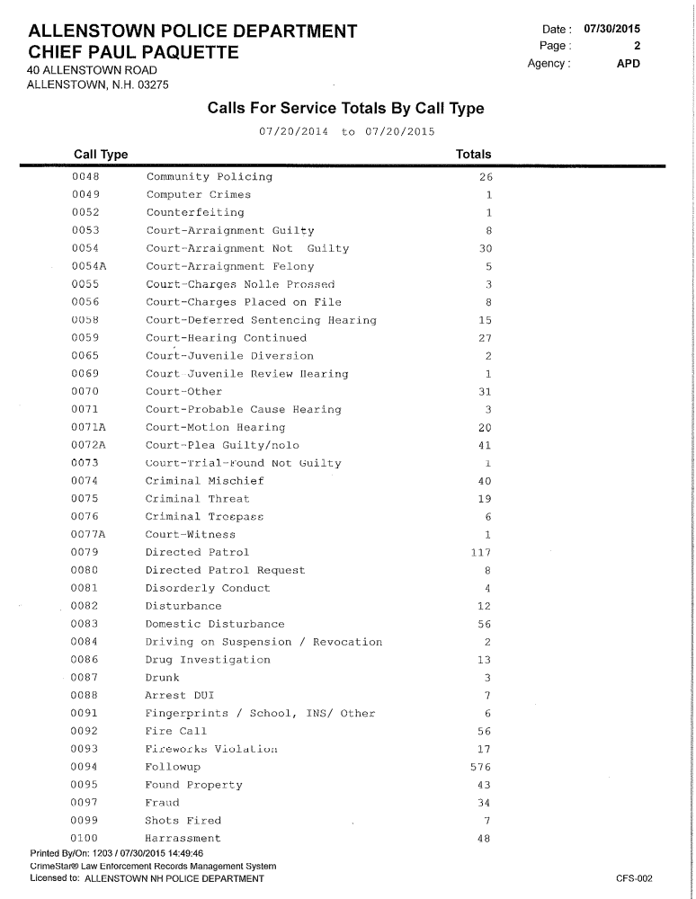

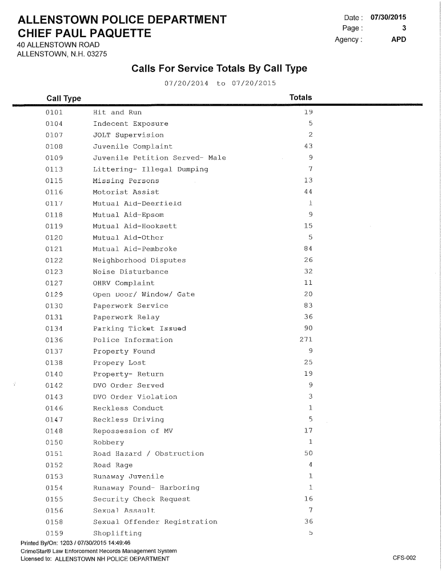

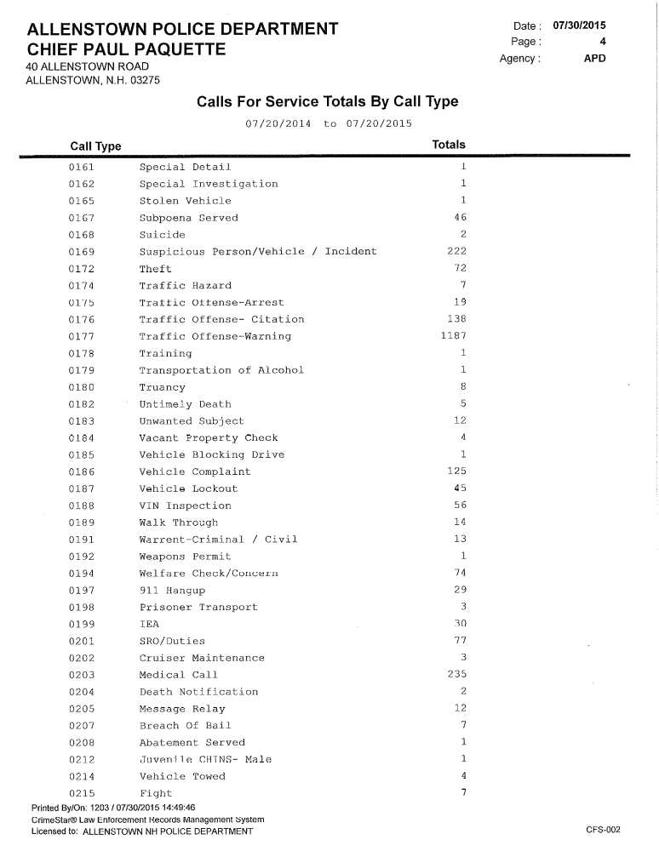

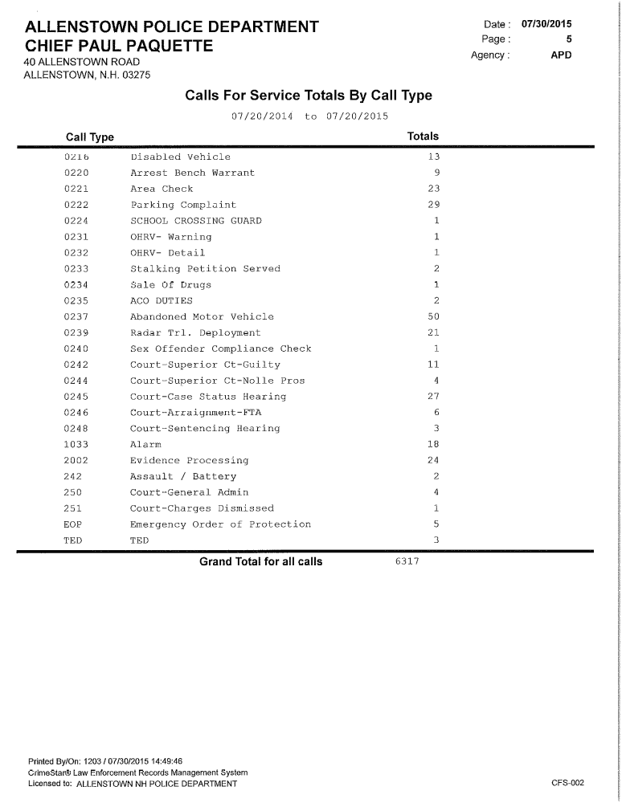

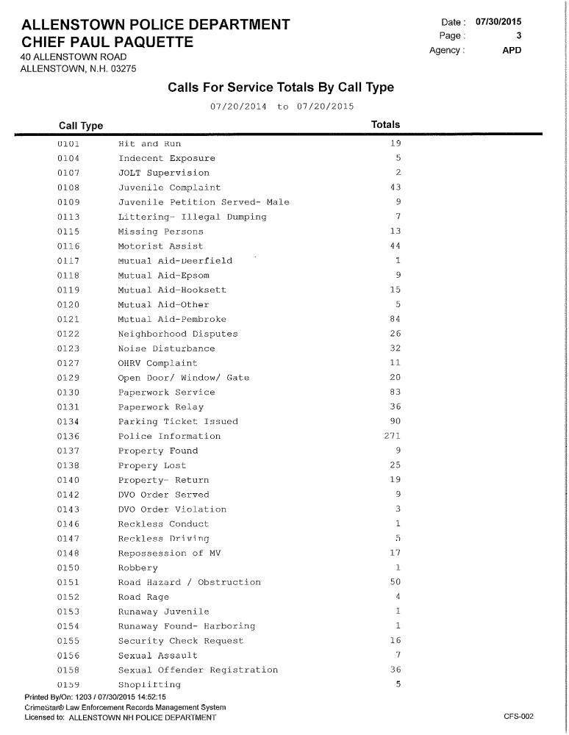

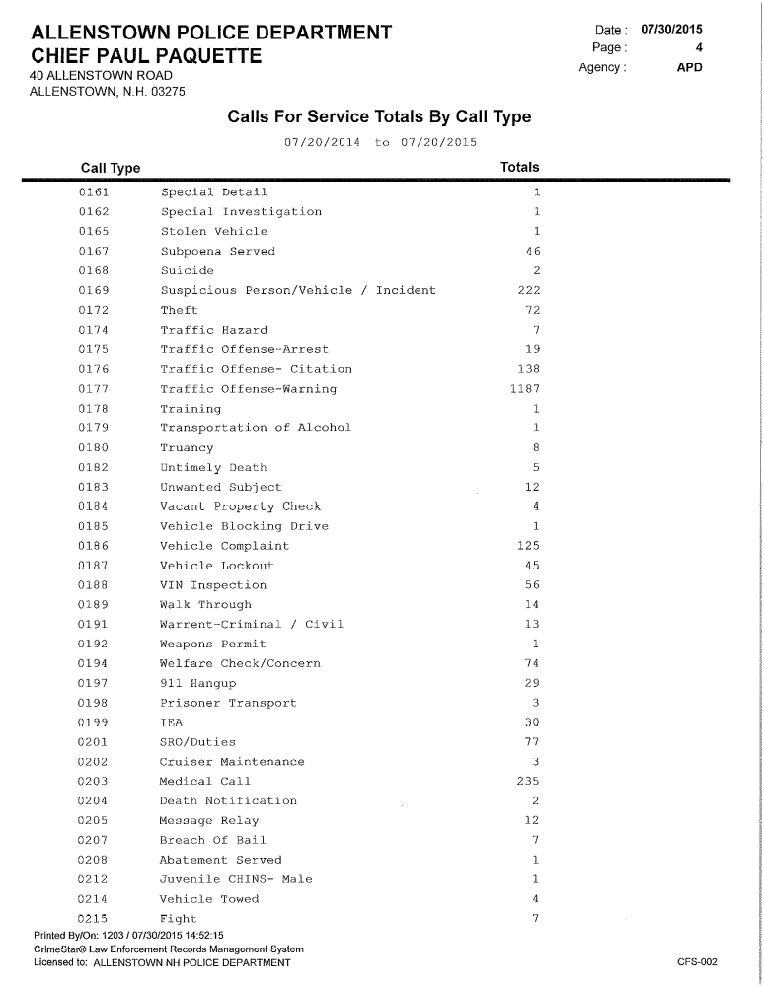

Employee Names |  | FT/PT | Hours per Week | Current Pay Rates |  | FY 2016
Employee Names | DEPT | FT/PT | Hours per Week | Current Pay Rates | New Pay Rate | 01/01/16-06/30/16 | 07/01/16-12/31/16 | Total Salary
Shea, Dawn | PD | FT | 40 | 28.85 | 29.14 | $ 30,004.00 | $ 30,304.04 | $ 60,308
Moeta, Luis | PD | FT | 40 | 19.68 | 19.88 | $ 20,467.20 | $ 20,671.87 | $ 41,139
Bowen, Michael | PD | FT | 40 | 19.68 | 19.88 | $ 20,467.20 | $ 20,671.87 | $ 41,139
Mounsey, Aaron | PD | FT | 40 | 19.68 | 19.88 | $ 20,467.20 | $ 20,671.87 | $ 41,139
Poppalardo, Christopher | PD | FT | 40 | 21.51 | 21.73 | $ 22,370.40 | $ 22,594.10 | $ 44,965
Vacant | PD | FT | 40 | 20.00 | 20.20 | $ 20,800.00 | $ 21,008.00 | $ 41,808
Paquette, Paul | PD | FT | 40 |  | 0.00 | $ 38,455.51 | $ 38,840.06 | $ 77,296
Stark, M | PD | FT | 40 | 31.68 | 32.00 | $ 32,947.20 | $ 33,276.67 | $ 66,224
Tower, B (B) | PD | FT | 40 | 28.03 | 28.31 | $ 29,151.20 | $ 29,442.71 | $ 58,594
Warburnton, Bryan | PD | FT | 40 | 19.98 | 20.18 | $ 20,779.20 | $ 20,986.99 | $ 41,766
Wilcox, Brian | PD | FT | 40 | 19.88 | 20.08 | $ 20,675.20 | $ 20,881.95 | $ 41,557
Full Time |  |  |  |  |  |  |  | $ 555,934
Employee Names |  | FT/PT | Hours per Week | Current Pay Rates |  | FY 2016
Employee Names | DEPT | FT/PT | Hours per Week | Current Pay Rates | New Pay Rate | 01/01/16-06/30/16 | 07/01/16-12/31/16 | Total Salary
Chabot, D | Admin PD | FT | 40 | 19.32 | 19.51 | $ 20,092.80 | $ 20,293.73 | $ 40,387
Hey, Cheryl | Admin PD | PT | 20 | 15.39 | 15.54 | $ 8,002.80 | $ 8,082.83 | $ 16,086
Walch, Dorothy | Admin PD | FT | 40 | 33.42 | 33.76 | $ 34,760.91 | $ 35,108.52 | $ 69,869
Young, Erin | Admin PD | PT | 15 | 13.14 | 13.27 | $ 5,124.60 | $ 5,175.85 | $ 10,300
Admin |  |  |  |  |  |  |  | $ 136,642

Animal Control Budget

In 2014 we eliminated the Animal control Officer position in order to reduce the budget. I am requesting $500 for miscellaneous supplies to include food, maintenance the kennel and propane.

1-4414.10-110 Animal Control Officer
Appropriated in 2015 $0.
Requested in 2016 $0

1-4414.10-610 ACO- Misc. Supplies
Appropriated in 2015 $500
Requested in 2016 $500

1-4414.10-626 ACO - Gasoline
Appropriated in 2015 $0
Requested in 2016 $0

